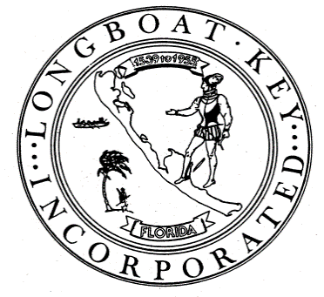
Town of Longboat Key Planning & Zoning Board
Town Hall, 501 Bay Isles Road
Longboat Key, FL 34228
www.longboatkey.org
David Lapovsky, Chair; Jay Plager, Vice Chair; Paul Hylbert, Secretary;
Ron Ginsberg; Nicholas Gladding; Margaret Nuzzo

AGENDA
REGULAR MEETING

MARCH 17, 2026 – 9:15 AM
- Call to Order
- Pledge of Public Conduct
- We may disagree, but we will be respectful of one another.
- We will direct all comments to issues.
- We will avoid personal attacks.
- Audience members wishing to speak must be recognized by the Chair.
- Speaking without being recognized will be considered as “Out of Order.”
- Public to be Heard
Opportunity for Public to Address Planning & Zoning Board
At each meeting, the Planning & Zoning Board sets aside time for the public to address issues not on the agenda.
- Approval of Minutes:
February 23, 2026 Regular Meeting Minutes
- Setting Future Meeting Date: April 13, 2026 Special Workshop and April 21, 2026 Regular Meeting
- Consent Agenda
The purpose of the Consent Agenda is to expedite those items on an agenda that appear to be of a routine nature. Any item on the Consent Agenda can be removed from the Consent Agenda and placed on the Regular Meeting Agenda by any member of the Planning & Zoning Board without having to make a motion, receive a second, or submit to a vote. Otherwise, all items on the consent Agenda are voted upon in their totality by one action (motion, second and vote) and are not subject to discussion. A vote in the affirmative on the Consent Agenda is a vote of confirmation to the action noted in each item.
There are no items scheduled for the Consent Agenda.
- Public Hearings
  - Ordinance 2026-07, Amending Chapter 158, Zoning Code, Section 158.094, Yard Regulations, and Section 158.099, Structures Over Water
A privately initiated Zoning Text Amendment request to allow for privately owned and permitted groin structures that include a pedestrian walkway and that extend from the public beach into the Gulf of America (formerly known as the Gulf of Mexico), to have a single archway structure with an embedded sign identifying the responsible entity for the structure and groin may be allowed seaward of the erosion control line, provided the structure and sign comply with the requirements of Chapter 158 and Chapter 156 of the Town Code.
  - Ordinance 2026-08, Amending Chapter 156, Sign Code, Section 156.02, Definitions, and Section 156.07, Specific Sign Regulations
A Town-initiated Sign Code Amendment to allow for privately owned and permitted groin structures that include a pedestrian walkway and that extend from the public beach into the Gulf of America (formerly known as the Gulf of Mexico), to have a single archway structure with an embedded sign identifying the responsible entity for the structure and groin.
- Workshop Discussion Items
There are no Workshop Discussion Items
- New Business
There is no New Business
- Staff Update
- Planning & Zoning Board Member Comments
- Adjournment
No verbatim record by a certified court reporter is made of these proceedings. Accordingly, any person who may seek to appeal any decision involving the matters noticed herein will be responsible for making a verbatim record of the testimony and evidence at these proceedings upon which any appeal is to be based (see Section 286.0105, Fla. Stat.).
In accordance with the Americans with Disabilities Act and Section 286.26, F.S., persons needing a reasonable accommodation to participate in this proceeding should contact the Town Clerk’s office at 941-316-1999 seventy-two (72) hours in advance of this proceeding. If you are hearing impaired or require an alternative means of communication, utilize Florida Relay Service by dialing 7-1-1 (TTY) or one of the following toll-free numbers:
1-800-955-8770 (Voice), 1-800-955-1339 (ASCII), 1-877-955-8260 (VCO-Direct), or 1-800-955-5334 (STS).

