Memorandum

TO: Town Commission

FROM: Tom Harmer, Town Manager

DATE: June 13, 2018

SUBJECT: Proposed Resolution 2018-20, Increasing the Sarasota County Phase III Infrastructure Surtax Budget FY2010 – FY2024 for Public Safety

**Recommended Action**

Following public hearing, adopt Resolution 2018-20.

**Background**

During the budget workshops we discussed that the remaining infrastructure surtax funds available for Public Safety Vehicles and Equipment is $341,674. The capital needs for public safety over the next five years total $2,675,000.

Proposed Resolution 2018-20 adds an additional $1,500,000 for public safety vehicles and equipment to the fifteen year budget, which began FY2010 and ends FY2024. The additional $1,500,000 is based on cumulative receipts and projected growth over the remaining six years. The Town will continue to monitor revenue projections over the remaining six years and make adjustments as necessary.

The Sarasota County Phase III Infrastructure Surtax referendum was passed in November of 2007 for revenue collection beginning in September of 2009 and continuing through FY2024.

The following requirements from Sarasota County Ordinance 2007-087, Section 5.H. addresses the authorization of the local governing body to adopt changes to the local funding allocations

*Modification to Projects and to Allocated Funding.*

*Each Local Governing Body shall have authority, after a public hearing, to adopt by resolution changes to the infrastructure projects to be funded and to reallocate its share of the Sales Tax proceeds.*

*Each Committee shall ensure that its Local Governing Body has followed the procedural requirements for making changes to the infrastructure projects or to the allocation of Sales Tax proceeds.*

Below is the scheduled replacement for Public Safety Vehicles and Equipment in our five-year Capital Plan.

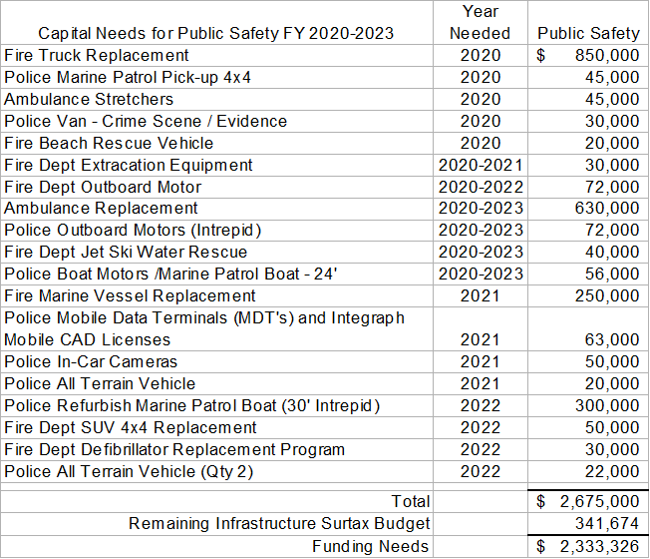

Attachment A of the Proposed Resolution “Exhibit F” shows the change to the budget.

Please don’t hesitate to contact me if you have any questions.

RESOLUTION 2018-20

**A RESOLUTION OF THE TOWN OF LONGBOAT KEY, FLORIDA, INCREASING THE SARASOTA COUNTY PHASE III LOCAL GOVERNMENT INFRASTRUCTURE SALES TAX BUDGET; PROVIDING FOR AN INCREASE IN THE TOWN’S FUNCTIONAL CATEGORY OF PUBLIC SAFETY; AMENDING THE TOWN’S DESIGNATED INFRASTRUCTURE SURTAX PROJECT BUDGET IN ACCORDANCE WITH SARASOTA COUNTY ORDINANCE NO. 2007-087; PROVIDING AN EFFECTIVE DATE.**

**WHEREAS,** In 1997, Sarasota County enacted Ordinance 97-083 (the “County Ordinance”) which provided for a one percent local government Infrastructure Sales Tax for the construction of infrastructure projects subject to referenda approval; and

**WHEREAS,** the voters within Sarasota County subsequently approved the Infrastructure Sales Tax (also known as Infrastructure Surtax); and

**WHEREAS,** Pursuant to Section 212.055(2), Florida Statutes, Sarasota County voters approved the extension of Phase II of the Sales Tax be continued commencing September 1, 2009 through December 31, 2024, with the extension known as Phase III; and

**WHEREAS,** at the request of Sarasota County, the Town of Longboat Key provided the County with a list of areas to be funded with the anticipated Infrastructure Surtax revenue, as well as Project Titles, and probable amounts to be allocated to each as reflected in Exhibit “F” of the County Ordinance; and

**WHEREAS,** the Infrastructure Surtax, Phase III, commenced on September 1, 2009, and will continue through December 31, 2024; and

**WHEREAS,** an additional $1,500,000 of revenue is expected based on cumulative receipts and projected growth over the remaining six years; and

**WHEREAS,** the Town Commission wishes to amend Exhibit “F” - Functional Area for “Public Safety”, increasing the total budget by $1,500,000; as reflected on Exhibit A attached hereto and fully incorporated herein; and

**WHEREAS,** in accordance with Sarasota County Ordinance 2007-087, Section 5.H., each Local Governing Body shall have the authority, after a public hearing, to designate changes to the infrastructure projects to be funded and to reallocate its share of the sales tax; and

**NOW, THEREFORE, be it resolved by the Town Commission of the Town of Longboat Key, Florida, that:**

SECTION 1. The above Whereas clauses are true and correct and are hereby ratified and confirmed.

SECTION 2. The Town Commission hereby amends Exhibit “F” of the Phase III Infrastructure Surtax program by increasing the funding allocation for the Functional Area of “Pubic Safety” by $1,500,000.

SECTION 3. Effective Date. This Resolution shall become effective immediately upon adoption.

Passed by the Town Commission of the Town of Longboat Key on the _____ day of ___________________, 2018.

______________________

George L. Spoll, Mayor

ATTEST:

________________________

Trish Shinkle, Town Clerk

Attachment: Exhibit “A”

**Exhibit A**

Amended Exhibit “F” of Sarasota County Ordinance 2007-087

|  |  |  |  |  |
| --- | --- | --- | --- | --- |
| **FUNCTIONAL AREA**  **CATEGORIES** | **PROJECT TITLE** | **CURRENT SURTAX FUNDING** | **SURTAX FUNDING REVISED** | **PROJECT IMPLEMENTATION DATE** |
| **COMPREHENSIVE BEACH MANAGEMENT** | **Longboat Key Beach Nourishment Project 2014 and Erosion Control Structures** | **$1,015,569** | **$1,015,569** | **FY2010 - FY2024** |
|  | **Comprehensive Beach Management Total** | **$1,015,569** | **$1,015,569** |  |
|  |  |  |  |  |
| **STREETS and DRAINAGE** | **Street Resurfacing and Drainage Improvements** | **$0** | **$0** |  |
|  | **Streets & Drainage Total** | **$0** | **$0** |  |
|  |  |  |  |  |
| **PARKS and RECREATION IMPROVEMENTS** | **Parks & Recreation Improvements** | **$2,922,000** | **$2,922,000** | **FY2010 - FY2020** |
|  | **Parks & Recreation Total** | **$2,922,000** | **$2,922,000** |  |
|  |  |  |  |  |
| **CANAL DREDGING** | **Dredging maintenance** | **$900,000** | **$900,000** | **FY2010 - FY2024** |
|  | **Canal Dredging Total** | **$900,000** | **$900,000** |  |
|  |  |  |  |  |
| **PUBLIC SAFETY** | **Police Patrol, Detective Vehicles and Radio Equipment**  **Fire and Rescue Capital Vehicle Acquisitions and Equipment** | **$2,303,168** | **$3,803,168** | **FY2010-FY2024** |
|  | **Public Safety Total** | **$2,303,168** | **$3,803,168** |  |
|  |  |  |  |  |
| **IMPROVEMENTS TO PUBLIC FACILITIES** | **Facilities Maintenance** | **$922,000** | **$922,000** | **FY2010 - FY2024** |
|  | **Public Facilities Improvements Total** | **$922,000** | **$922,000** |  |
|  | **Town of Longboat Key Infrastructure Surtax Project Grand Total** | **$8,062,737** | **$9,562,737** |  |
|  | **Town of Longboat Key Estimated Infrastructure Surtax Revenue FY 2010-FY 2024** | **$8,062,737** | **$9,562,737** |  |