**Uploading Revision Documents**

1. Have resident/contractor email requested documents.
2. Download documents.
3. In BS&A, under the review that is pending, select Documents>Add Document from the toolbar on the top.  
   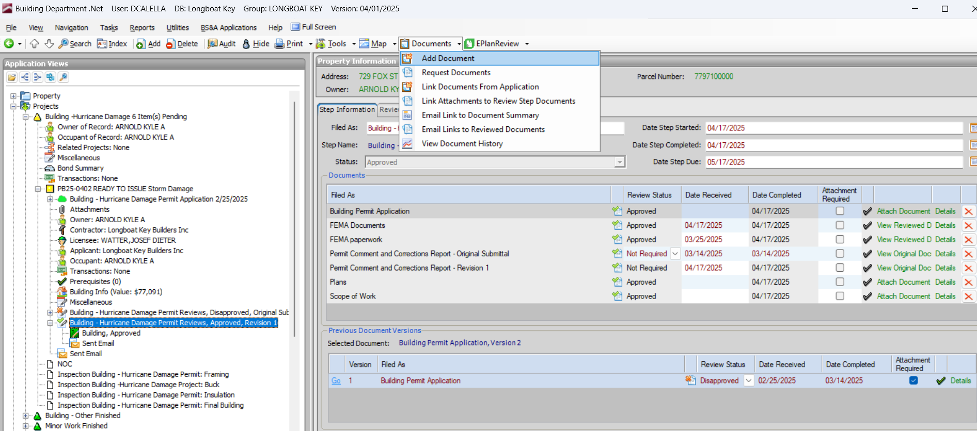
4. Under add document, fill in the document name and click “attach document”  
   Graphical user interface, text, application

   AI-generated content may be incorrect.
5. Select document for upload from the location they have been downloaded to, and then click add.
6. The document should populate automatically in the pending document reviews at the bottom. Click “Send document to EPlanReview” and complete review.  
   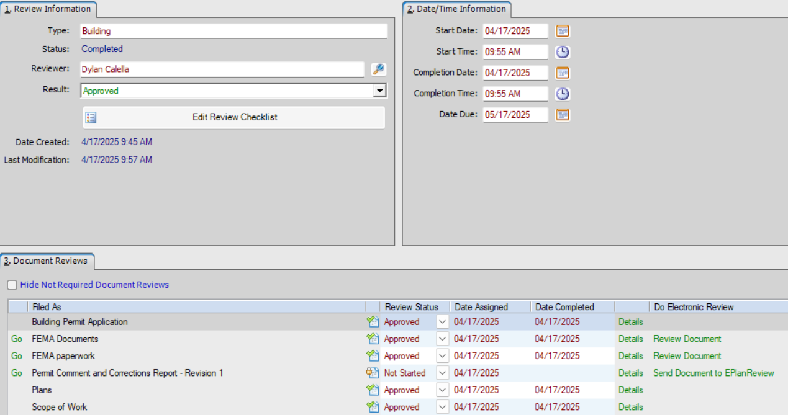

**IF “Send document to EPlanReview” does not work and it is unable to complete this step;**

1. Print the downloaded document, stamp with the approval stamp, scan and send to your email, and then add the document to the to the review as shown in steps 3-5.
2. Approve in BS&A to finalize.

**IF document is approved but no review is pending;**

1. Under the pending review, right click and click Add>Add New Review  
   Text

   AI-generated content may be incorrect.Graphical user interface, application

   AI-generated content may be incorrect.
2. Verify document that was uploaded is in the new review, send to EPlanReview or Print as needed based on previous guides.