Longboat Key Canal Maintenance Assessment Program Examples

Group 3 – Sandhamn HOA Subdivision
HOA with deeded assigned boat slips and common element unassigned boat slip
PID | Billable Units | PA Assigned Features | Explanation of Features associated with Parcel | Property Use Code | DOR_Description | LegalDescription1 | Canal | Group
Sandhamn Subdivision |  | Common Element Parcel has 8 boat slips - 7 are assigned to specific parcels; 1 shared proportionately by all HOA parcels
7992800107 | 1.11 | dock; assigned boat slip | boat dock at the property and assigned boat slip #7 on the common element parcel | 0100 | Single Family Residential (1554) | LOT 1 SANDHAMN SUB; TOGETHER WITH BOAT SLIP #7 (1598/5685) | 20P | 3
7992800156 | 1.11 | boat lift; assigned boat slip | nothing on property; assigned boat slip #2 with lift on common element parcel | 0100 | Single Family Residential (1554) | LOT 2 SANDHAMN SUB; TOGETHER WITH ASSIGNED BOAT SLIP #2 | 20P | 3
7992800206 | 1.11 | dock | boat dock at property and assigned boat slip #5 on common element parcel | 0100 | Single Family Residential (1554) | LOT 3 SANDHAMN SUB; TOGETHER WITH ASSIGNED BOAT SLIP #5 | 20P | 3
7992800255 | 1.11 | dock; assigned boat slip | boat dock at property and assigned boat slip #6 on common element parcel | 0100 | Single Family Residential (1554) | LOT 4 SANDHAMN SUB; TOGETHER WITH ASSIGNED BOAT SLIP #6 | 20P | 3
7992800305 | 1.11 | assigned boat slip | parcel not abutting; assigned boat slip #3 on common element parcel | 0100 | Single Family Residential (1554) | LOT 5 SANDHAMN SUB; TOGETHER WITH ASSIGNED BOAT SLIP #3 | 20P | 3
7992800354 | 1.11 | assigned boat slip; boat lift | parcel not abutting; assigned boat slip #1 with lift on common element parcel | 0100 | Single Family Residential (1554) | LOT 6 SANDHAMN SUB ; TOGETHER WITH ASSIGNED BOAT SLIP 1 | 20P | 3
7992800404 | 1.11 | assigned boat slip | parcel not abutting; assigned boat slip #4 on common element parcel | 0100 | Single Family Residential (1554) | LOT 7 SANDHAMN SUB; TOGETHER WITH ASSIGNED BOAT SLIP #4 | 20P | 3
7992800453 | 1.11 | dock | dock at property; no assignment of boat slip | 0100 | Single Family Residential (1554) | LOT 8 SANDHAMN SUB PI#79928.0045/3 | 21 | 3
7992800503 | 2.11 | 2 docks | 2 docks at property; no assigned boat slip | 0100 | Single Family Residential (1554) | LOT 9 SANDHAMN SUB PI#79928.0050/3 | 21 | 3
7992800602 | 0 | assigned boat slip | common element parcel assigned boat slip #8 | 0900 | Vacant Residential Common Area (1554) | TRACT B SANDHAMN SUB; TOGETHER WITH BOAT SLIP #8. | 20P | 3
Total Units | 10.99

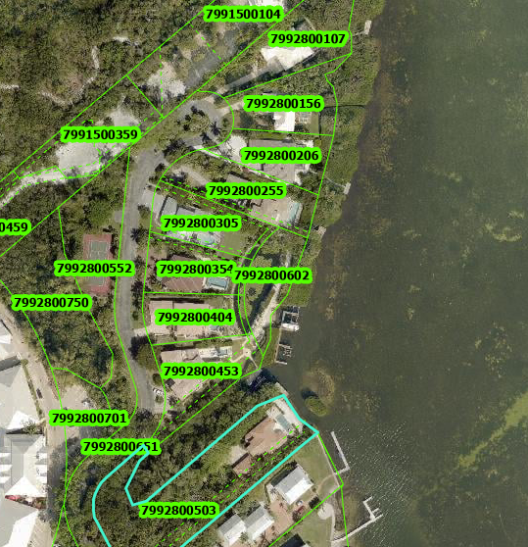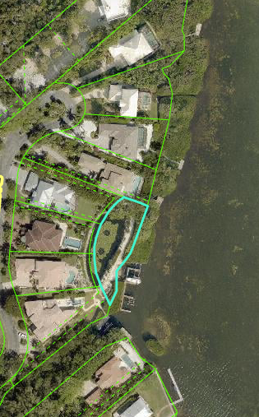
Group 2 -- Laguna Yacht Village Condo
Condo Complex with 10 Boat Slips – 1 of the boat slips is assigned to a non-abutting, non-condo parcel
PID | Billable Units | PA Assigned Features | Explanation of Features Associated with Parcel | Property Use Code | DOR_Description | LegalDescription1 | Canal | Group
Laguna Yacht Village Condo
7840200559 | 1 | boat lift | legal description has assigned boat slip | 0410 | Single Family Homes/Land Condo (1554) | UNIT 1 LAGUNA YACHT VILLAGE A CONDO TOGETHER WITH BOAT SLIP | 11B | 2
7840200609 | 1 | assigned boat slip | legal description has assigned boat slip | 0041 |  | UNIT 2 LAGUNA YACHT VILLAGE A CONDO; TOGETHER WITH BOAT SLIP | 11B | 2
7840200659 | 1 | none | legal description has assigned boat slip | 0410 | Single Family Homes/Land Condo (1554) | UNIT 3 LAGUNA YACHT VILLAGE A CONDO; TOGETHER WITH BOAT SLIP | 11B | 2
7840200709 | 1 | assigned boat slip | legal description has assigned boat slip | 0410 | Single Family Homes/Land Condo (1554) | UNIT 4 LAGUNA YACHT VILLAGE A CONDO; TOGETHER WITH BOAT SLIP | 11B | 2
7840200759 | 1 | none | legal description does not have assigned boat slip; Warranty Deed assigns Boat Slip #9 | 0410 | Single Family Homes/Land Condo (1554) | UNIT 5 LAGUNA YACHT VILLAGE A CONDO PI#78402.0075/9 | 11B | 2
7840200809 | 1 | none | legal description does not have assigned boat slip; Warranty Deed assigns Boat Slip #8 | 0410 | Single Family Homes/Land Condo (1554) | UNIT 6 LAGUNA YACHT VILLAGE A CONDO PI#78402.0080/9 | 11B | 2
7840200859 | 1 | none | legal description does not have assigned boat slip; Warranty Deed assigns Boat Slip #10 | 0410 | Single Family Homes/Land Condo (1554) | UNIT 7 LAGUNA YACHT VILLAGE A CONDO; TOGETHER WITH BOAT SLIP | 11B | 2
7840200909 | 1 | none | legal description does not have assigned boat slip; Warranty Deed assigns Boat Slip #2 | 0410 | Single Family Homes/Land Condo (1554) | UNIT 8 LAGUNA YACHT VILLAGE A CONDO; TOGETHER WITH BOAT SLIP | 11B | 2
7840200959 | 1 | boat lift |  | 0410 | Single Family Homes/Land Condo (1554) | UNIT 9 AND BOAT SLIP NO 8 LAGUNA YACHT VILLAGE A CONDO | 11B | 2
7840201009 | 0 | boat house; dock; 4 boat lifts; | common element parcel - visually can see there are 10 boat slips, some with lifts | 0941 | Improved Condo Common Area (1554) | COMMON AREA LAGUNA YACHT VILLAGE PI #78402.0100/9 | 11B | 2
7840200153 | 1 | boat lift | Even though not a part of the Laguna Yacht Village Condo; it owns Boat Slip #5 | 0100 | Single Family Residential | LOT 2 LAGUNA AT LONGBOAT KEY TOGETHER WITH EXCLUSIVE USE OF BOAT SLIP #5 AS DEPICTED ON THE PLAT OF LAGUNA YACHT VILLAGE REC IN CB 30, PG 27 PI#78402.0015/3
Total | 10

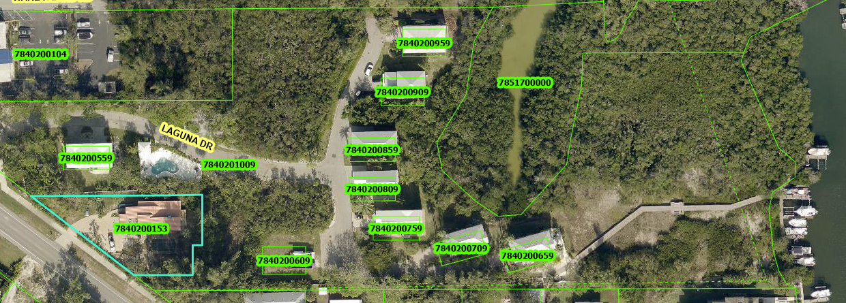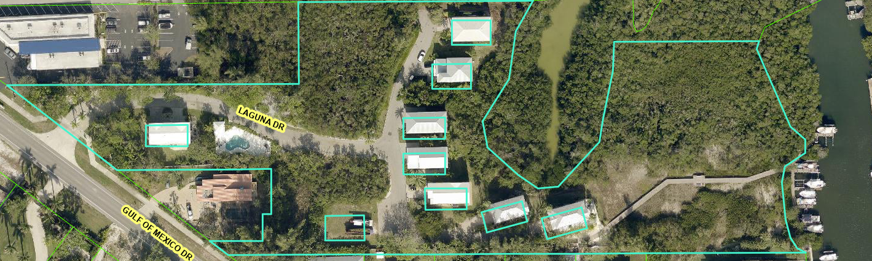

Laguna Yacht Village Condo – Warrant Deed Excerpts
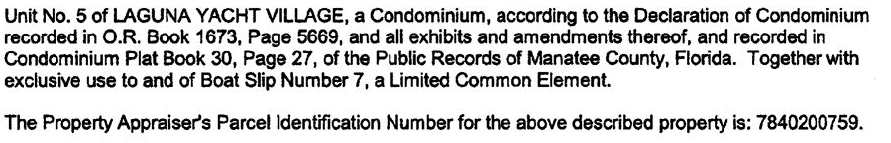

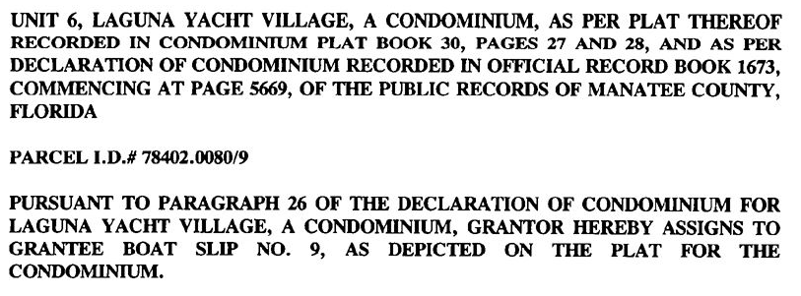

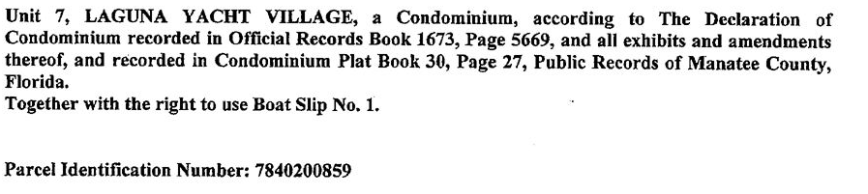

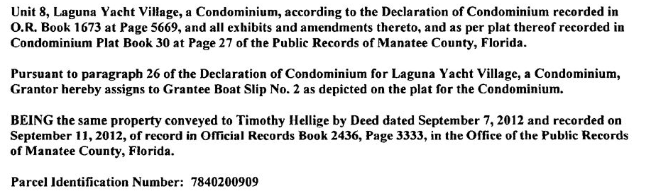

Buttonwood Cove Condo Association
- 56 Condo Units
- 17 total boat slips
- 3 Boat Slips Assigned
  - 3 condo units will be assigned 1.25 water access units (1 for their assigned unit and .25 for their share of the common element water access units)
- 14 Boat Slips Unassigned
  - 53 condo units will be assigned their proportionate share of the common element boat slips
    - (14 water access units ÷ 56 condo units = .25 water access units for each condo unit)

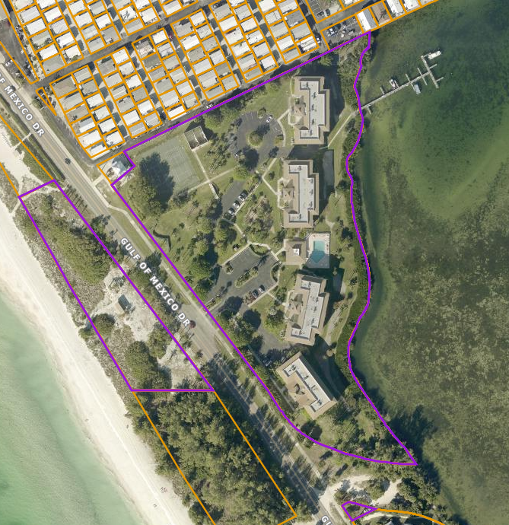

BUTTONWOOD HARBOR HOA

- Only abutting parcels or parcels with assigned boat docks/boat slips by the Property Appraiser will be charged.

PID - 0006050018 – Buttonwood Harbor Assn Inc – common element parcel with 8 boat slips and private boat ramp
LOT 4 LESS WLY 20 FT THEREOF ALL LOTS 3 & 55 & LOT 54 LESS WLY 10 FT THEREOF & LESS TRACT TO VERVAEKE IN OR 259/465 BLK 10 REPLAT OF BLKS 1 2 3 5 10 11 12 14 15 & 16 LONGBOAT SHORES REVISED IN OR 369/421 VALUE REFLECTED IN INDIVIDUAL LOTS IN LONGBOAT SHORES REVISED, INCLUDES 19700 C-SF SUBMERGED LANDS
- While the value of the common elements have been reallocated by the Property Appraiser to the HOA parcels; the details are not provided in the parcel data; therefore, the 8 HOA common element boat slips have not been reallocated. Only abutting parcels and parcels with boat docks and assigned boat slips have been charged.
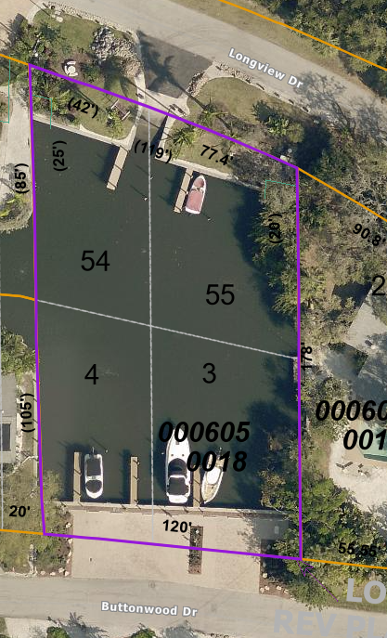

PID – 0003150007 – Island Court Homeowners Assn Inc. – submerged land with 5 boat docks - VALUES REFLECTED IN OWNERS OF LOTS 1 THROUGH 5, BLK 5 OF SAID LONGBOAT SHORES REV
- boat dock feature has been assigned by Property Appraiser to the 5 lots/parcels
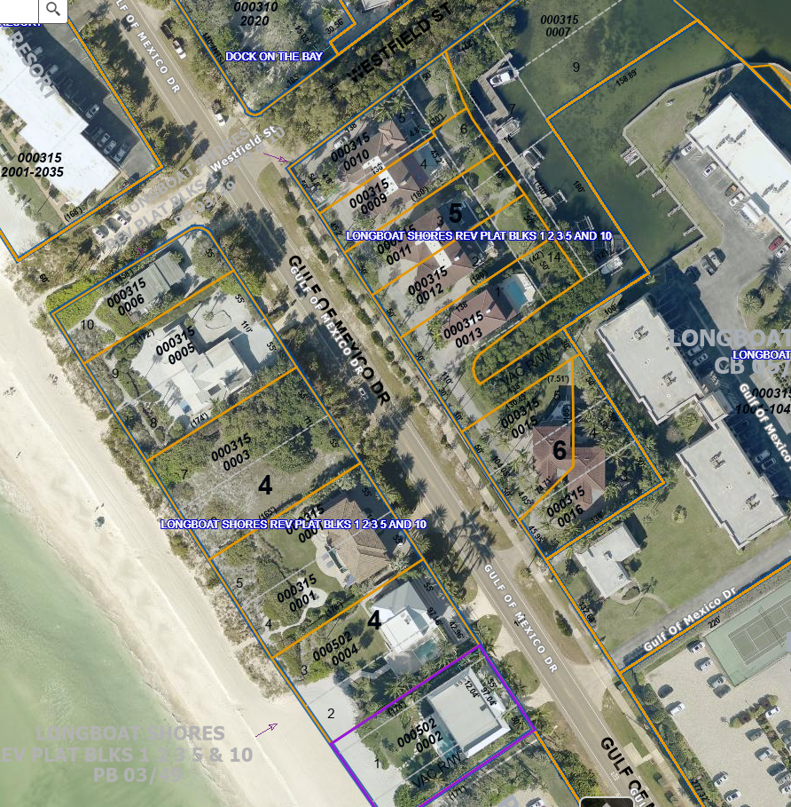

Subdivisions 0715 Longboat Shores and 6703 Buttonwood Harbor
Total 77 Parcels -- 37 abutting and 40 non-abutting
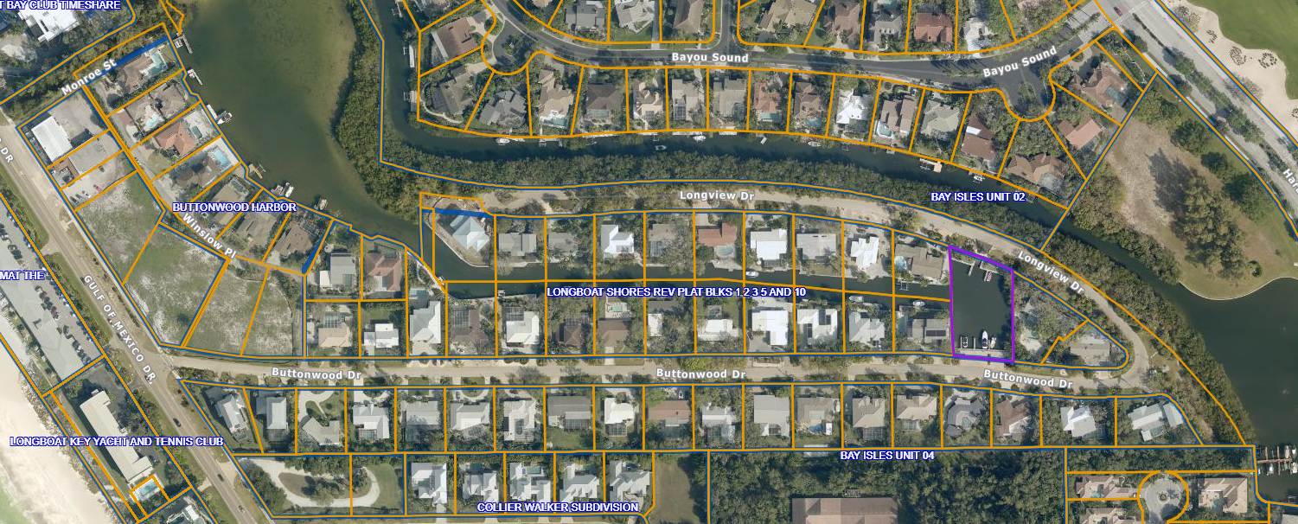
Note, not always does the Property Appraiser readily identify the parcels associated with an HOA, as was the case with Buttonwood Harbor/Longboat Shores. And in this case, the Property Appraiser did not identify the extra features associated with the common element parcel. In this case, the common element boat slips and boat ramp were not identified, and therefore, not reallocated back to the HOA members.

Note, not always does the Property Appraiser readily identify the parcels associated with an HOA, as was the case with Buttonwood Harbor/Longboat Shores. And in this case, the Property Appraiser did not identify the extra features associated with the common element parcel. In this case, the common element boat slips and boat ramp were not identified, and therefore, not reallocated back to the HOA members.

