Input Hard Copy MEPs Permit Application

Search for Address (F6) or Ctrl+F (for Permit Number)

Add new Permit Application-In the tree look for the Permit Application Type

Contractor-Search for the Contractor by putting the name of the Company in search mode.

Click OK and this will automatically populate the information.

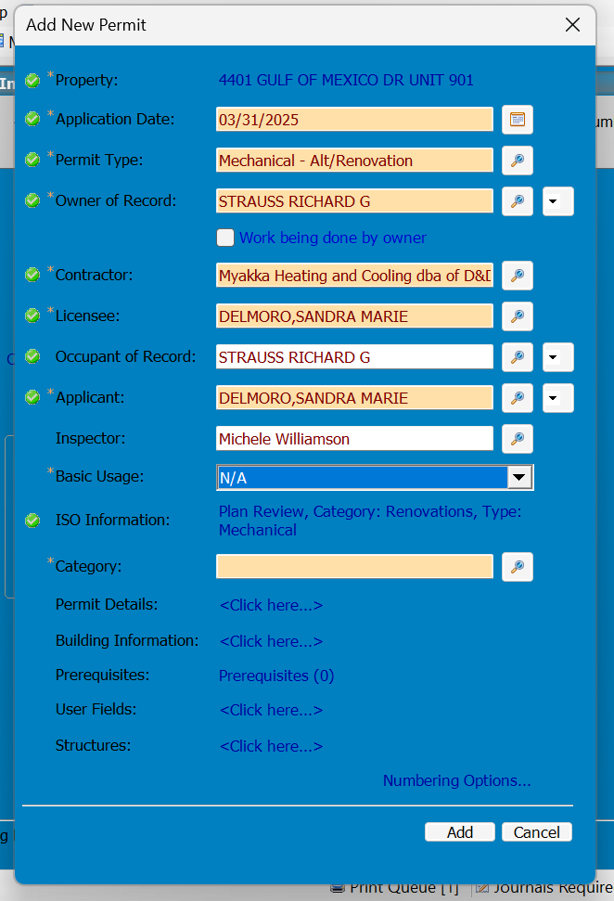

Basic Usage you will choose either Commercial or Residential

Category

You will choose either Alteration or A/C Change Out

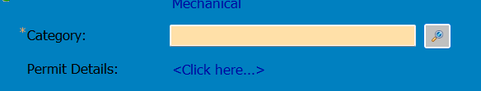

Click OK

Permit Details you will put the work description in

In the General Tab

In the Miscellaneous Fields Tab, you will fill out the required information.

In the Construction Details the Basic Usage automatically populates, you will need to add the Construction Value amount, you will find that on front page of the Hardcopy Application.

Click OK

Then click Add

Select Optional Process Steps

Click Cancel

Add Invoice

This is an alteration permit, so you will choose the Alterations Additions & Repairs fee amount.

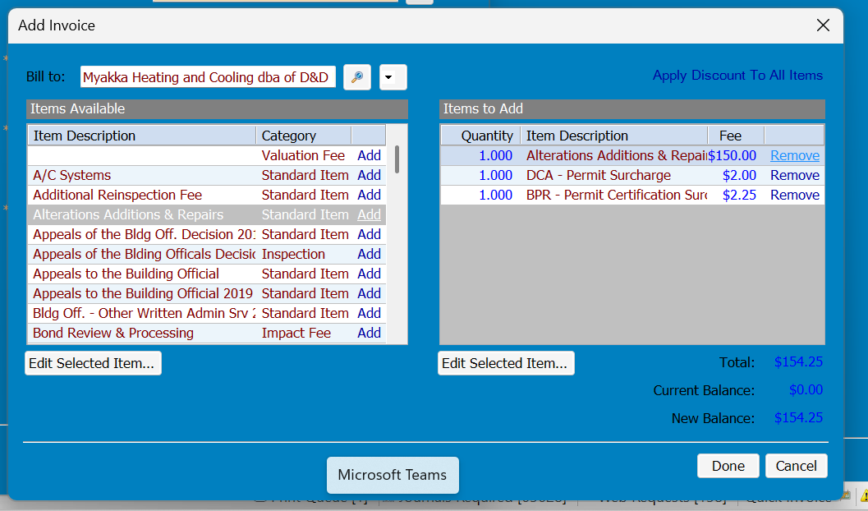

Then click Done

It will then take you back to the permit.

Scan the hard copy permit application and upload the documents.

Add the documents

Attach External Documents and click OK

When attaching the documents you will click open on the correct file and rename it-Permit Application.

Click OK

Back under the tree you will then choose the Mechanical-Alt/Renovation Permit Reviews, Not Started

From there you will attach the application and send to E-Plan.

Documents-Click Add Documents

Under Filed As, but the name of the document (Permit Application)

Attachment: Attach Document, is where you will upload the document-View the Document and then click Add

After that you will send the document to E-Plan.

Click the Start Step and Send Documents to EPlanReview

Click OK

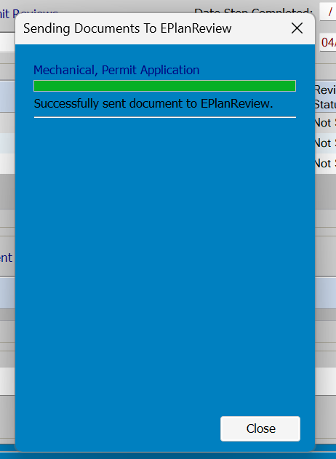

Double check and make sure the Reviewer’s name is Patti Fige.