TOWN OF LONGBOAT KEY

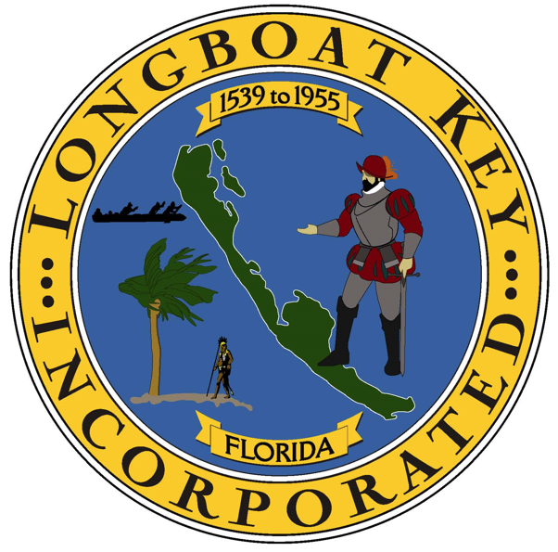

Cynthia Barnette
Volunteer

