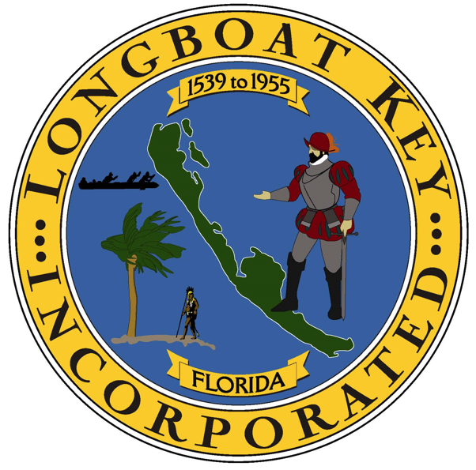

TOWN OF LONGBOAT KEY

Camela Cherry

