TOWN OF LONGBOAT KEY

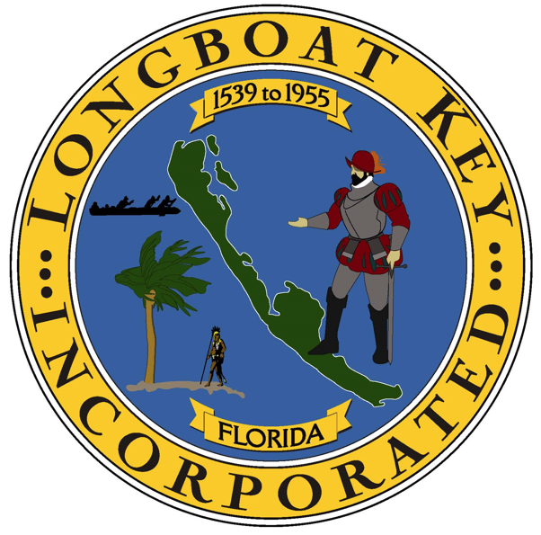

Francisco Pena
Employee #1035

Date of Hire: 8/26/2025

