TOWN OF LONGBOAT KEY

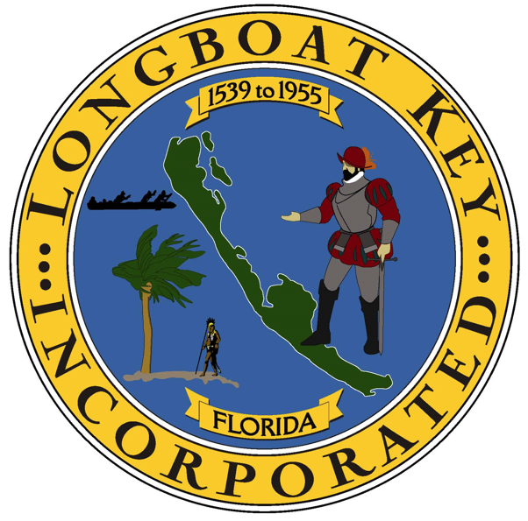

6/27/2025

