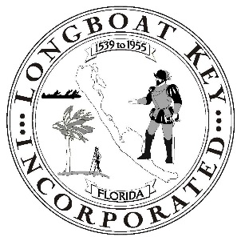

TOWN OF LONGBOAT KEY

EMPLOYEE OATH OR AFFIRMATION

I, __________________________________, do solemnly swear (or affirm) that I am a citizen of the United States and a resident of the State of Florida, or duly authorized to work in the State of Florida, and being employed by or an officer of the Town of Longboat Key and a recipient of public funds as such employee or officer, will support, protect and defend the Constitution and Government of the United States and of the State of Florida.

___________________________________  
Employee Signature

STATE OF FLORIDA  
COUNTY OF SARASOTA

Sworn to (or affirmed) and subscribed before me this ______ day of ___________, 20____, by   
  
______________________________________________.

_______________________________________  
 (Signature of Notary Public – State of Florida)

______________________________________  
 (Print, Type, or Stamp Name and Commission  
 Expiration date of Notary Public)

Personally Known _____ OR Produced Identification

___________________________________________________