FIRST AND FOREMOST – ALL CANCELLATION LETTERS MUST BE REVIEWED/APPROVED BY THE BLDG OFFICIAL – PATTI FIGE

1. LTR FROM THE CONTRACTOR -  on letter head, address to The Town of LBK Bldg Official – Patti Fige, reason for cancellation (i.e. no work was done), permit #, address of property, letter must be signed (prefer notarized but mandatory)
2. NEXT LTR FROM THE HOMEOWNER on record-  ltr addressed to The Town of LBK Bldg Official – Patti Fige, reason for cancellation(i.e. no work was done), permit# address of property, letter must be signed (prefer notarized but mandatory)

TO CANCEL A PERMIT – CTRL F OR  F6  (TO FIND ADDRESS OR  PERMIT RECORD#) –

STIPULATION (DATE – LETTERS TO CANCEL PERMIT # APPROVED BY PATTI FIGE BUILDING OFFICIAL).

PUT THE YELLOW HIGLIGHT IN THE STIPULATIONS….. don’t forget  ☹

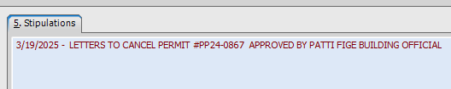

PP24-0867 – PERMIT – RIGHT CLICK TOOLS/CHANGE STATUS/CANCEL.



UPLOAD ATTACH SCAN COPY OF LETTERS….

right click to attach  “ATTACH EXTERNAL… -  ADD copy of ltr

DON’T FORGET AFTER YOU ARE DONE… MUST EMAIL COPY OF THE SIGNED (APPRVD BY PATTI)  LETTER TO THE CUSTOMER AND CONTRACTOR…