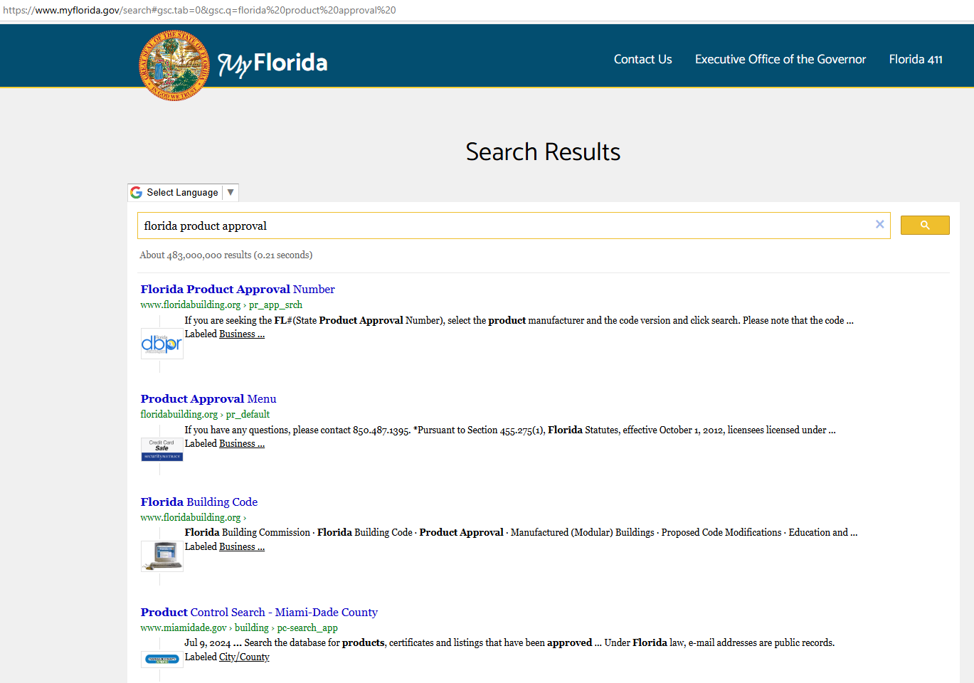

FLORIDA PRODUCT APPROVAL
Roofing, siding, nails, fastners – anything to do with instructions

