Damage Assessment –Windshield Survey LBK 8-5-24

Damage Assessment – LBK 8-5-24 – Michele Williamson- Locations of likely structure damage due to flooding. Identified locations were viewed via LBK FD high-water vehicle.
Note: As of approx. 12pm on 8-5-24: Almost all streets in the Village are flooded:
- 6809 Pine St. entire yard submerged with signs of intrusion.
- 620 Jackson Way – Road was flooded. Visible water lines.
- Lois Ave. – Entire street was flooded. Visible signs of intrusion.
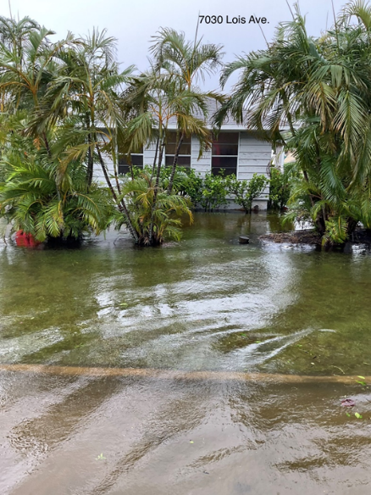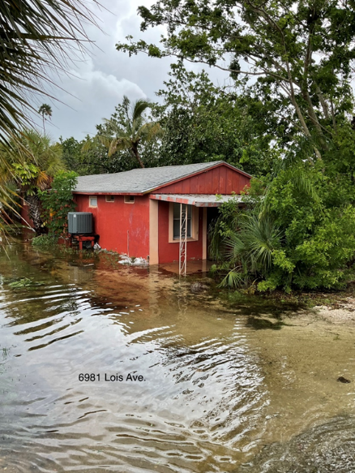
- Lindley Street Dock is submerged.
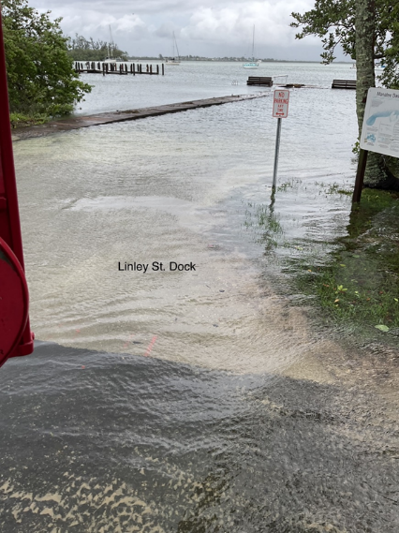
- Broadway, Longboat Dr. E, Longboat Dr. N, Fox, Russell, Poinsettia north of Broadway all streets flooded and multiple houses with signs of intrusion.
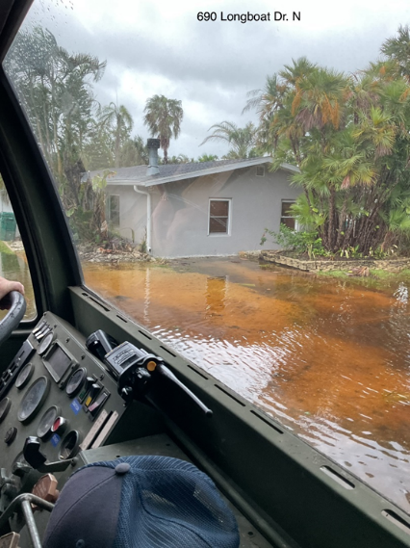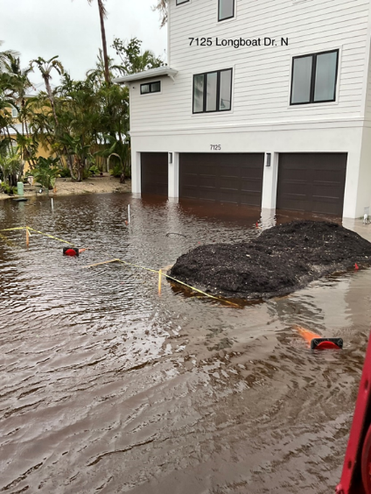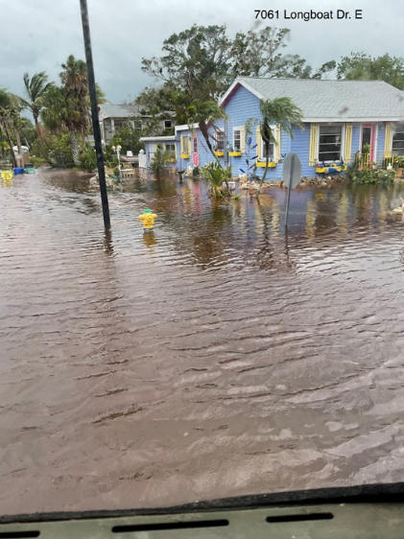
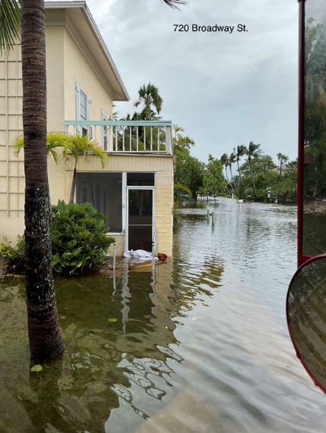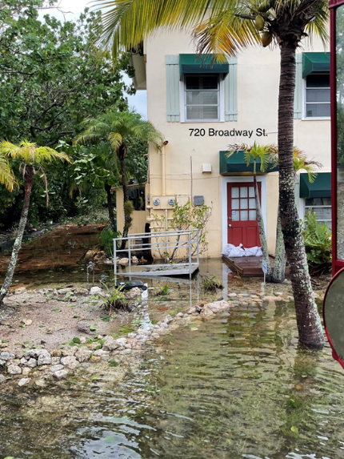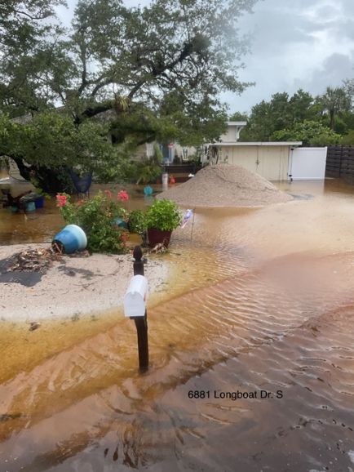
- Lands End was all clear – no signs of flooding.
- Lyons Lane – Completely flooded with multiple houses showing signs of intrusion. Water is at or over seawalls.
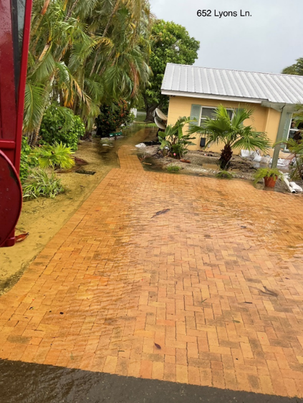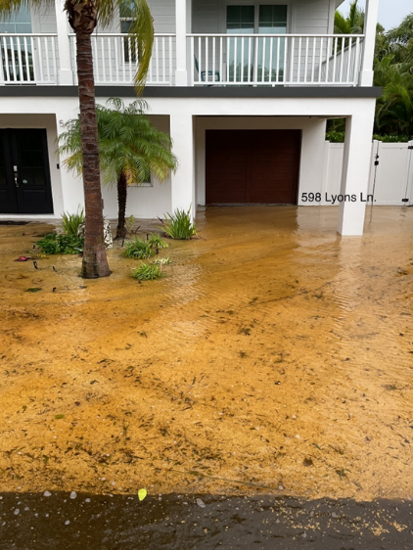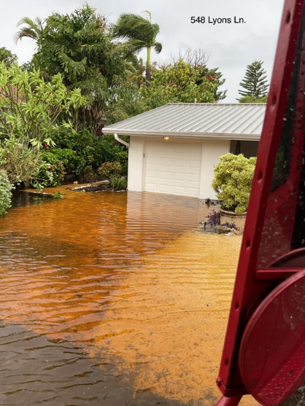

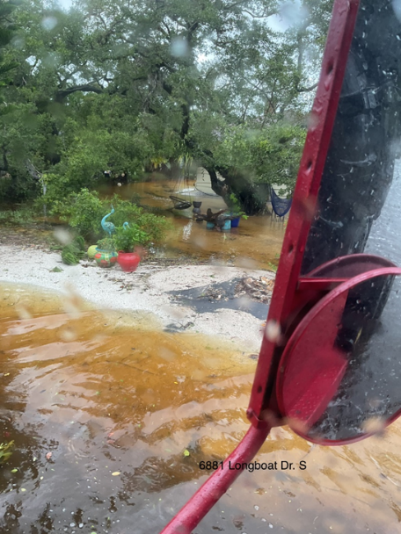
- Bayview Dr. – Street completely flooded – multiple houses show signs of intrusion.
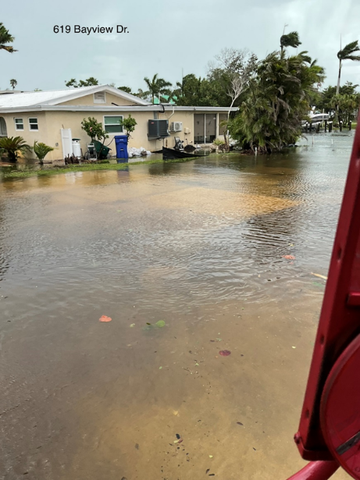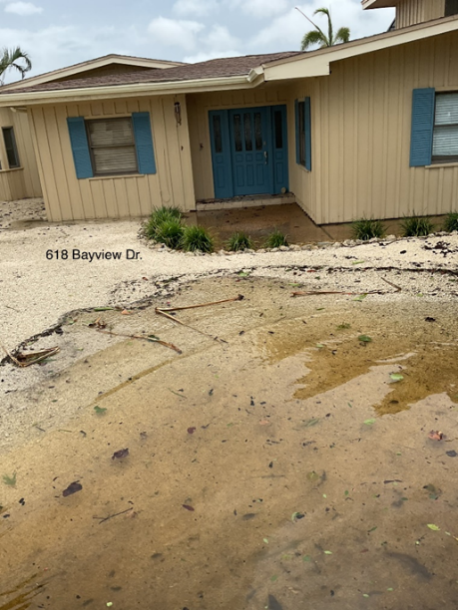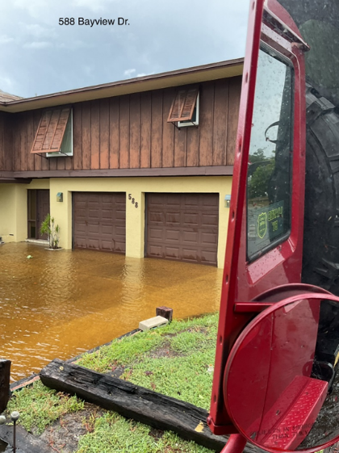

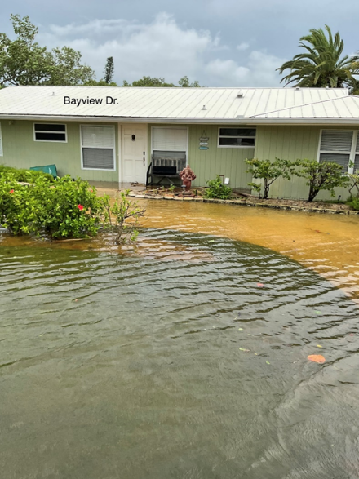

- Penfield St. – Completely flooded – multiple houses show signs of intrusion. Water is at or over seawalls.
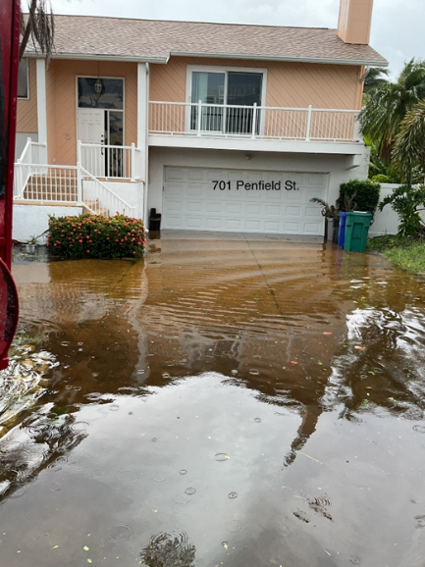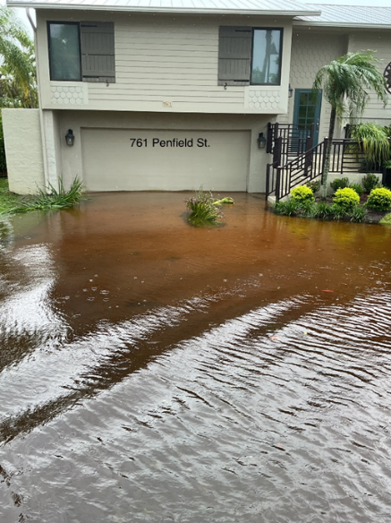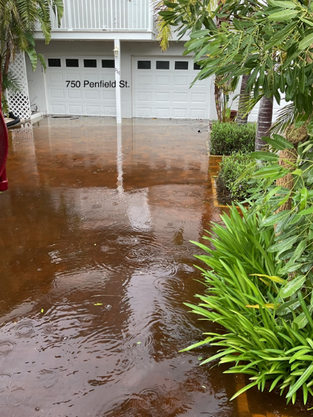
- Marbury Lane – Completely flooded – multiple houses showing signs of intrusion. Water is at or over seawalls.
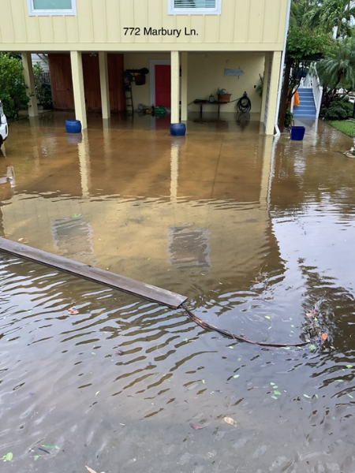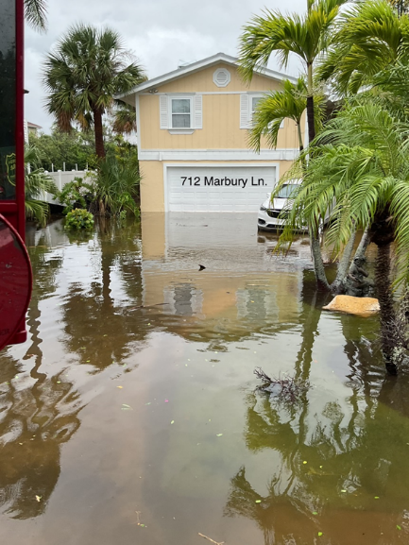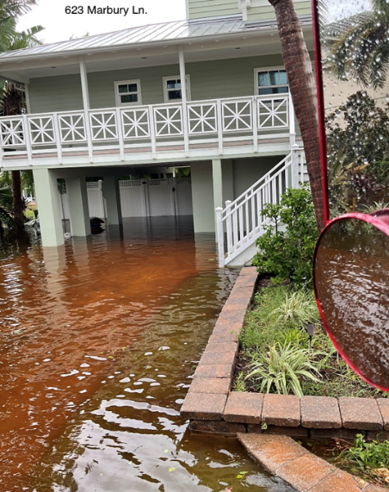

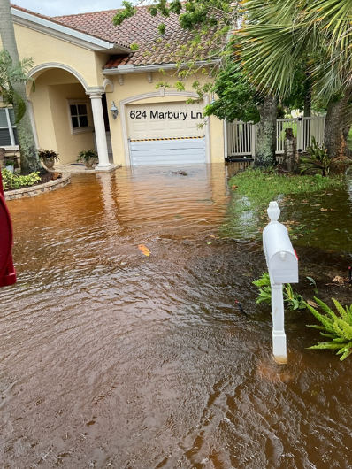

- Norton St. – Completely flooded – multiple houses showing signs of intrusion. Water is at or over seawalls.
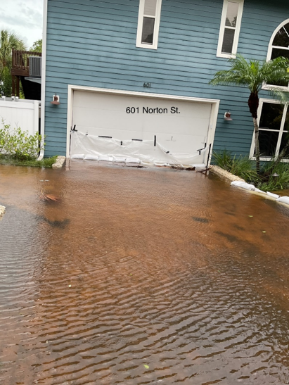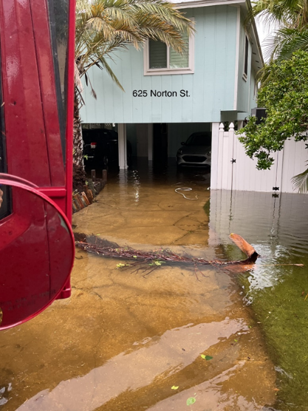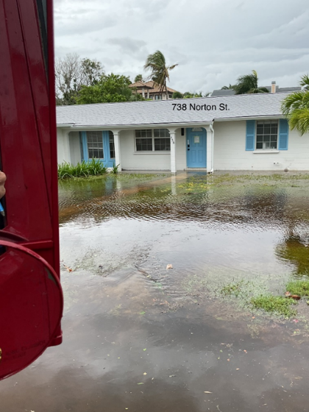

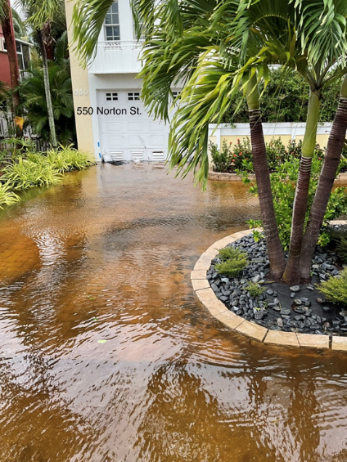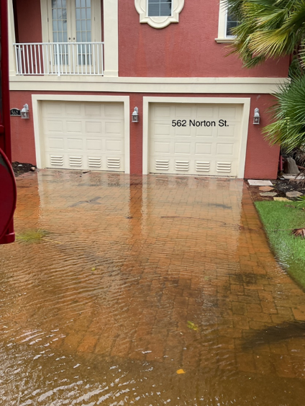

- Gulfbay Rd. – Street flooded – 3 houses at the East end show signs of intrusion (650, 660, & 691)
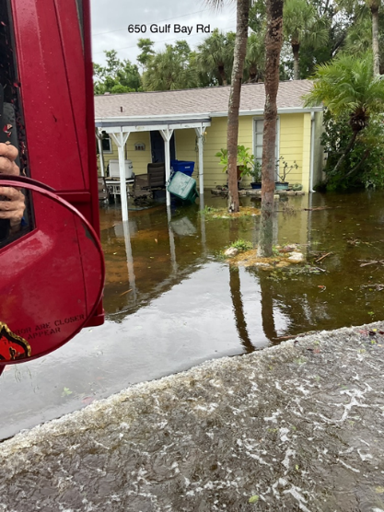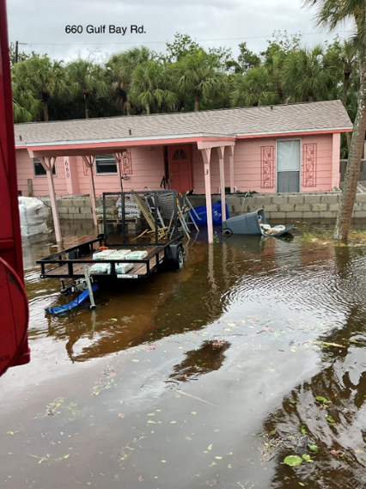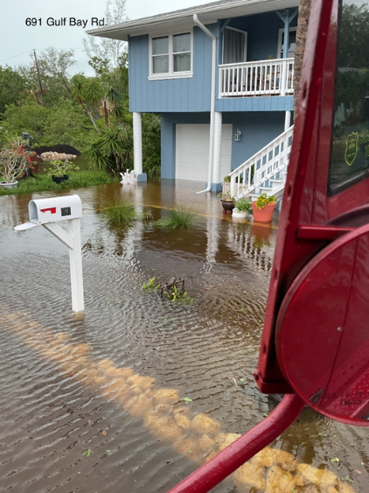
- Buttonwood Dr. – Street completely flooded – no visible signs of intrusion.
- Longview Dr. – Portions of street flooded – No visible signs of intrusion.
- Titon and Neptune – No flooding
- Pyrula – Completely flooded through to Triton. No visible signs of intrusion or water lines.
- 644 St. Judes’s Dr
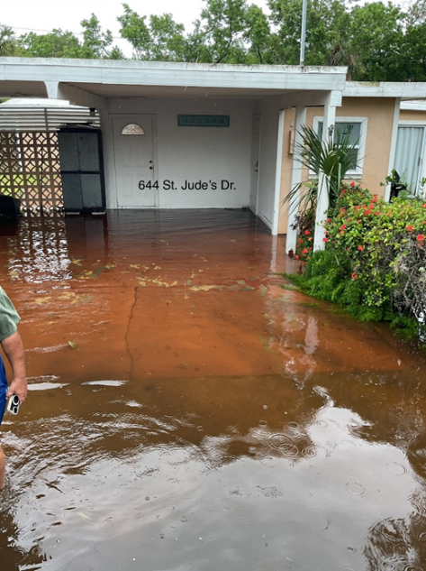
- 641 St. Judes’s Dr
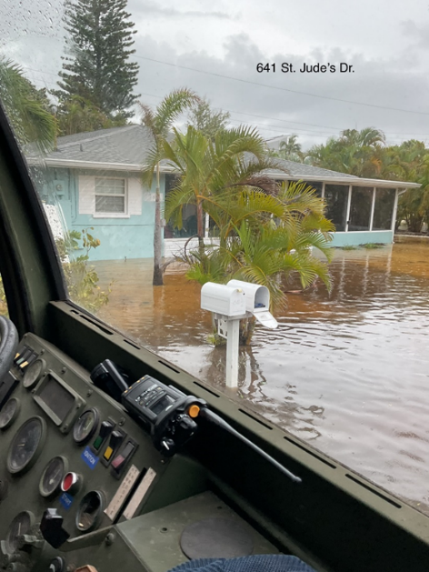

Damage Assessment – LBK 8-5-24 – David Woods- Identified locations were viewed via Town vehicle. Areas of high-water were not able to be inspected.
- St. Judes Dr. – Completely flooded. No visible water lines but I know that 631 and 641 had water intrusion.
- Tarawitt Dr. – Road was flooded. No visible water lines but a resident told me they had 8 inches of water. Minimal water intrusion and they were able to clean it up with towels.
- Jungle Queen Dr. – Road was flooded. No visible signs of water intrusion.
- Gulf Shore (MH Park) – Spoke to maintenance, they stated the typical flooding of the clubhouse, pool, and the units on the ground. Water line visible on E13.
- Twin Shores – Road completely flooded at the Bay. No visible water lines.
- Kingfisher Dr. – Power/Cable line down from tree limbs.
- Royal Rd. – Power pole is leaning.
- Gulf Side Rd. – Road completely flooded. Visible water line at 6441 GSR.
- De Narvaez – Road flooded. 560 had water at the foundation of the house.
- Juan Anasco Dr. – Road flooded. No visible water lines.
- Dream Island – Road flooded. No visible water lines.
- Edlee Lane – Road flooded. No visible water lines.

Damage Assessment – LBK 8-5-24 – Chief Dezzi.

Here is what has been reported as flooded streets:
- 6550 Gulf of Mexico Dr. - Heavy flooding, 8" deep.
- 6390 Gulf of Mexico Dr. - Heavy flooding, 8" deep.
- 5278 Gulf of Mexico Dr. - Heavy flooding, 4-6" deep.
- 4562 -4765 Gulf of Mexico Dr - Heavy flooding, 12" deep.
- General Harris St - Heavy flooding, impassable.
- Dream Island - Heavy flooding, impassable by vehicles.
- Edlee Lane - Heavy flooding, impassable by vehicles.
- St. Judes Dr - seawater flooding streets. Impassable.
- Buttonwood Dr - Heavy flooded, 8" deep.
- North Shore
- All streets in Village are flooded. Impassable at 600 Broadway.
Damage Assessment – LBK 8-5-24 – Patti Fige. No structural damage identified. Photos & locations depict street flooding.
- Zota – 4711 Gulf of Mexico Dr – Picture #1 & #2

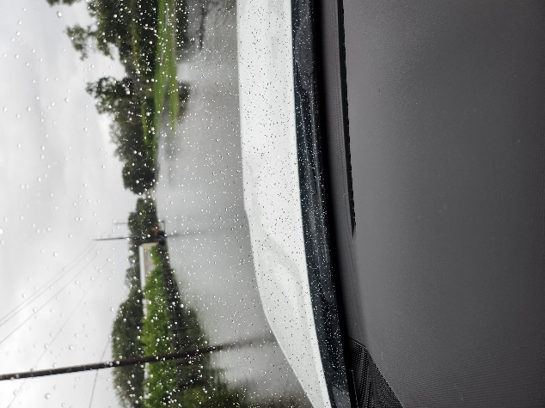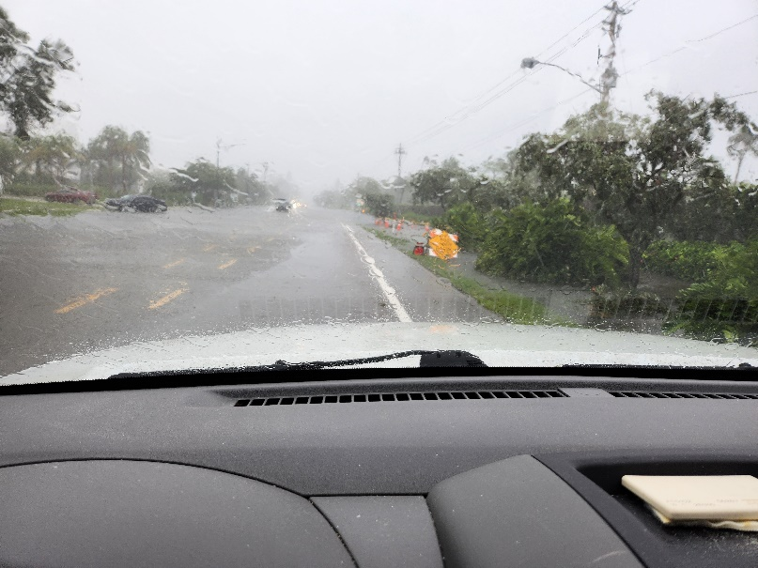

- Gulfside – Broadway & Firehouse

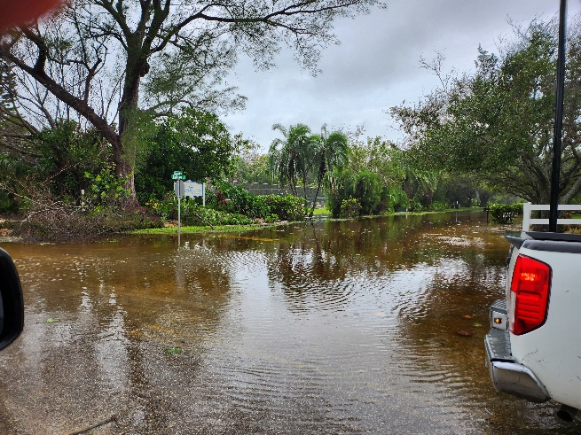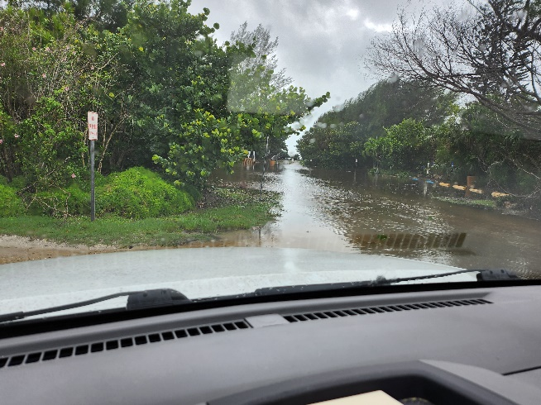

- 6305 Gulf of Mexico Drive
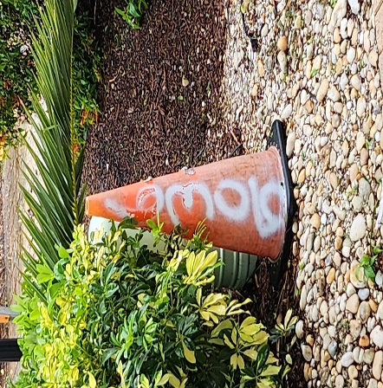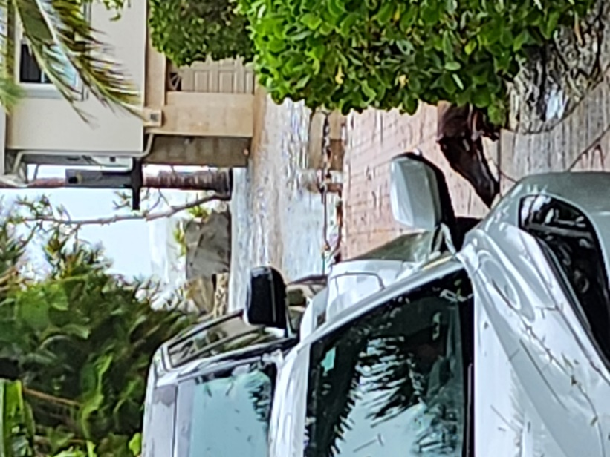

- 6252 Gulf of Mexico Dr
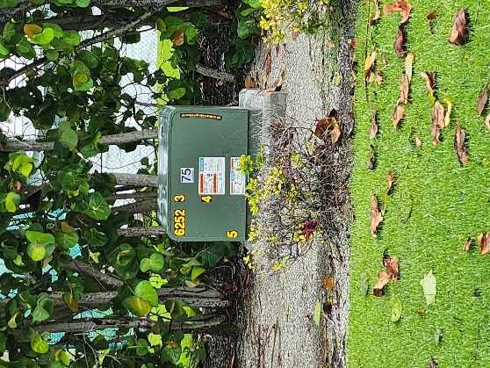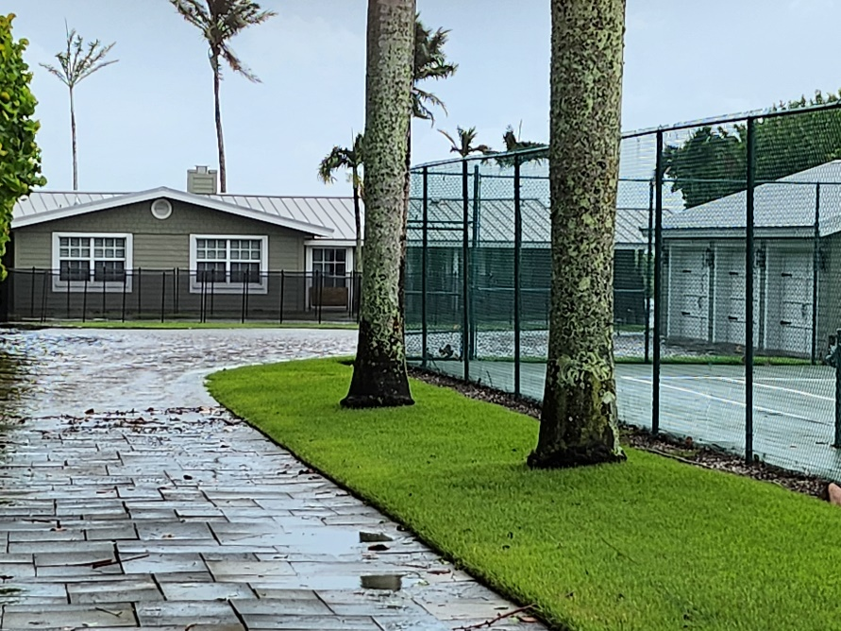

- Continued - 6252 Gulf of Mexico Dr

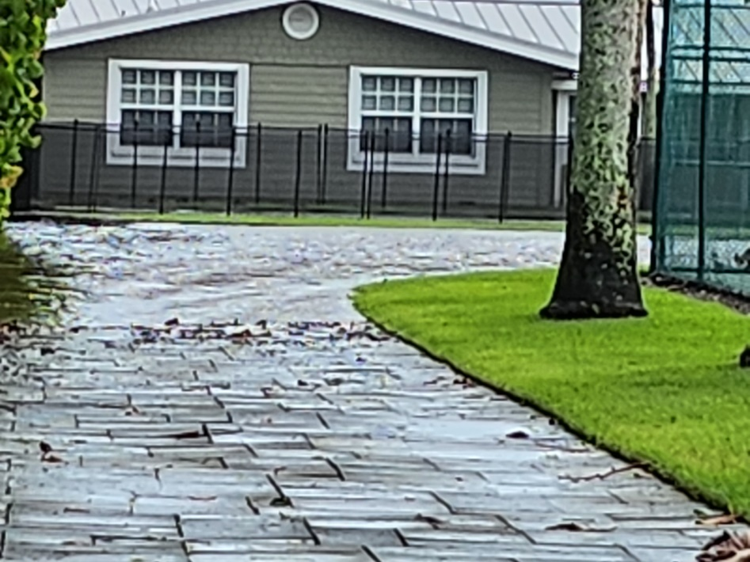

- Covert II - 5231 Gulf of Mexico Dr
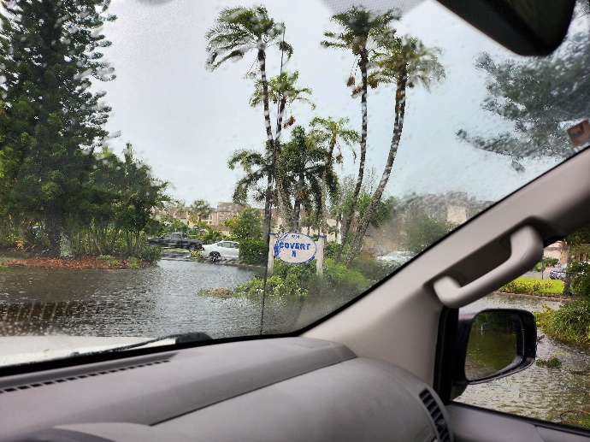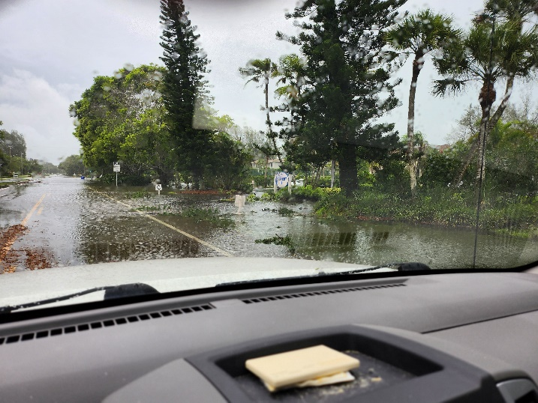

- Covert III – 5211 Gulf of Mexico Dr

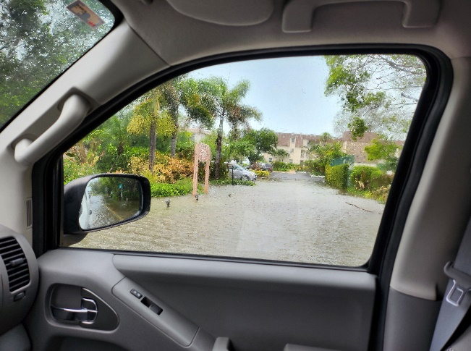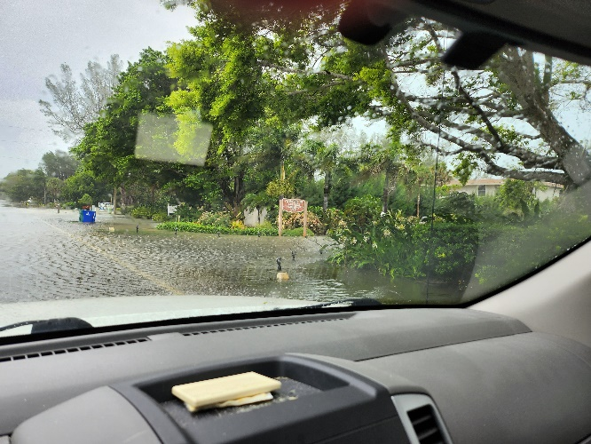

- Outrigger Resort – 5155 Gulf of Mexico Dr

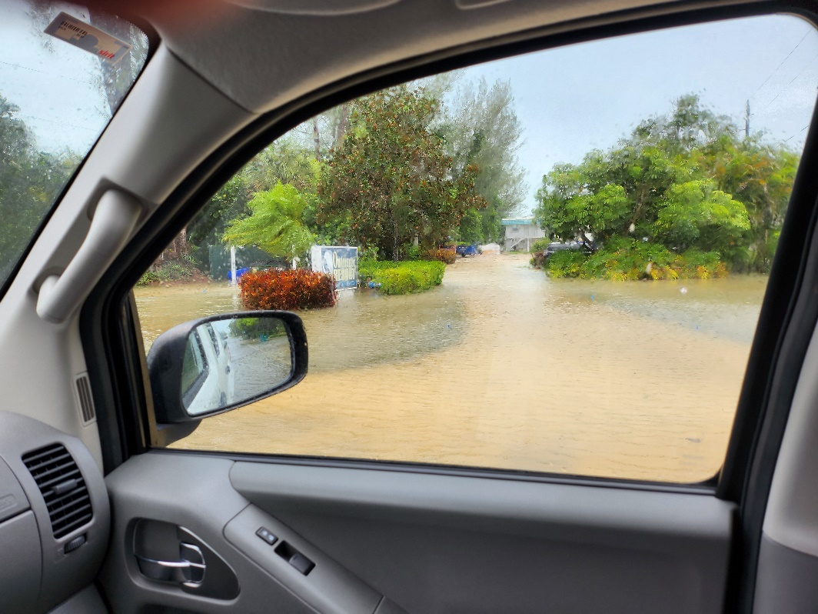

- Seascape – 5135 Gulf of Mexico Dr

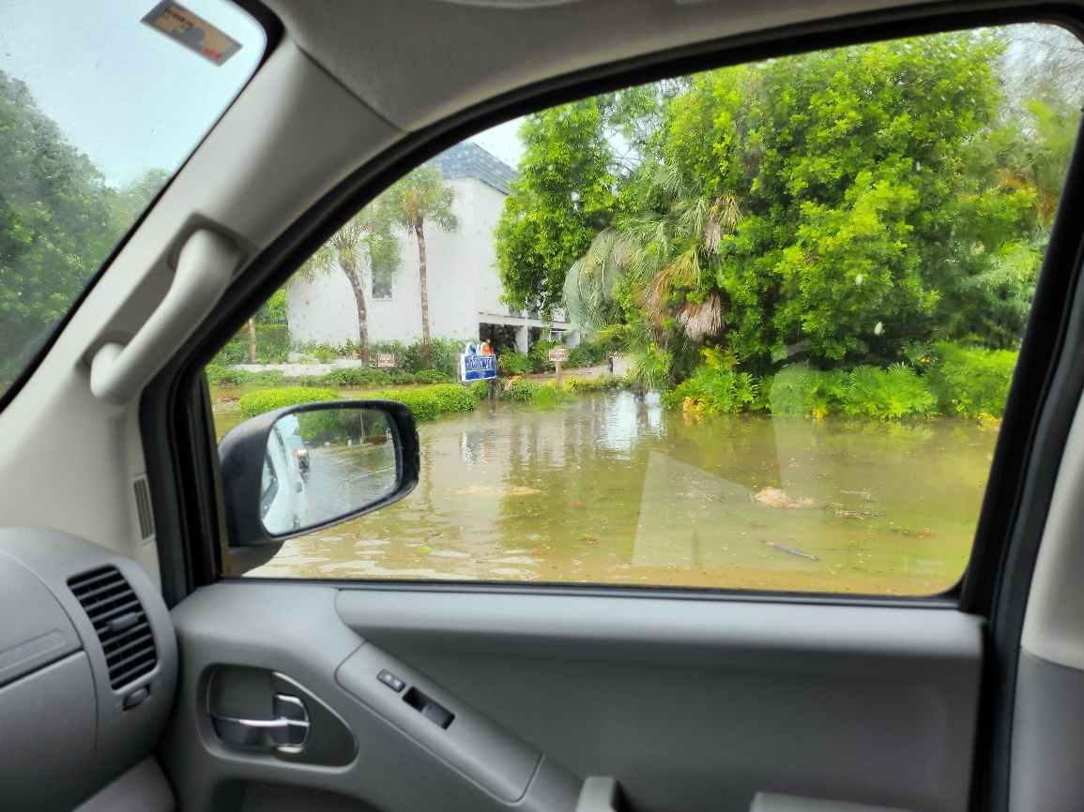

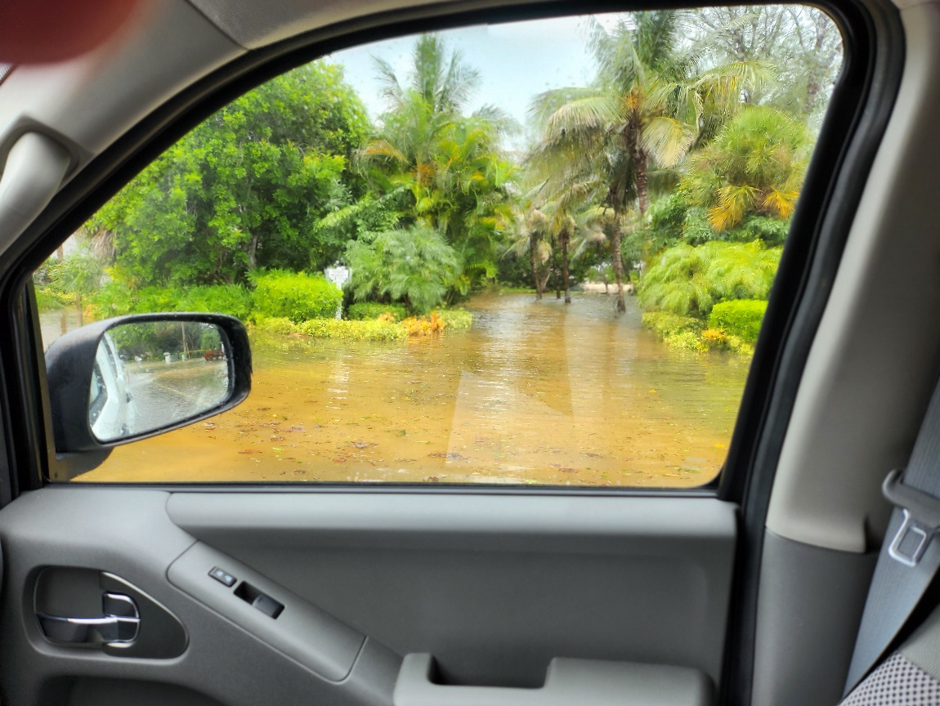

Damage Assessment – LBK 8-5-24 – Allen Parsons. No structural damage identified. Photos & locations depict street flooding.

- Buttonwood Dr. Entrance
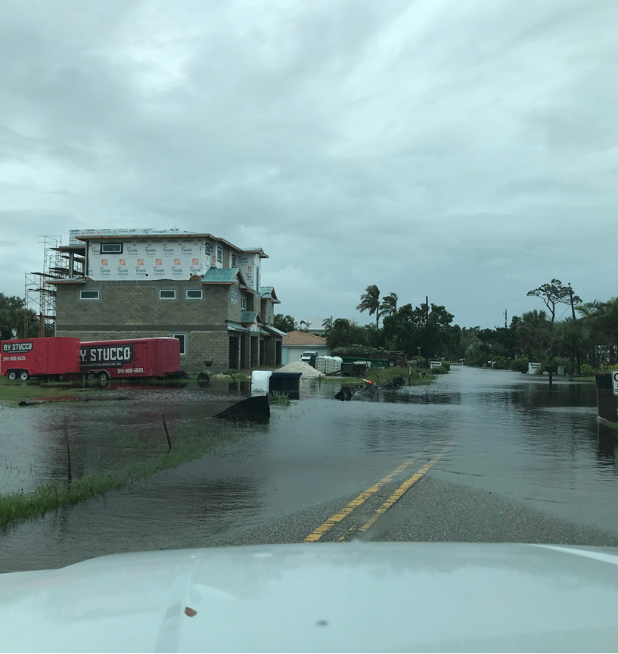
- Kingfisher Lane- Street Flooding
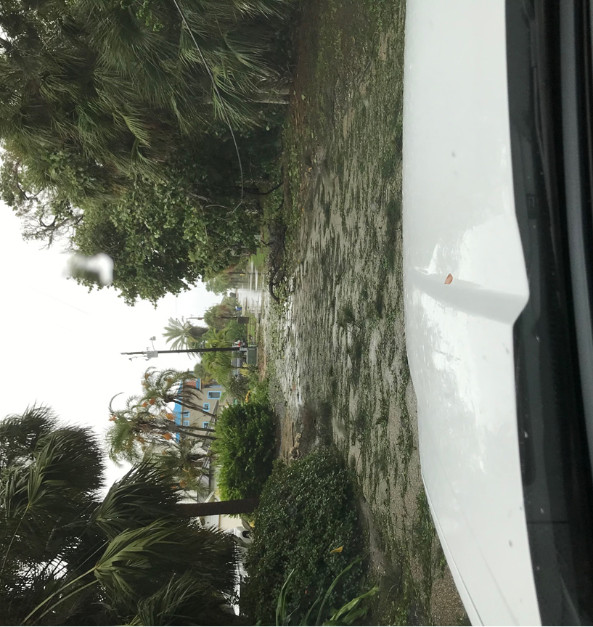
- Rountree Dr. Street Flooding
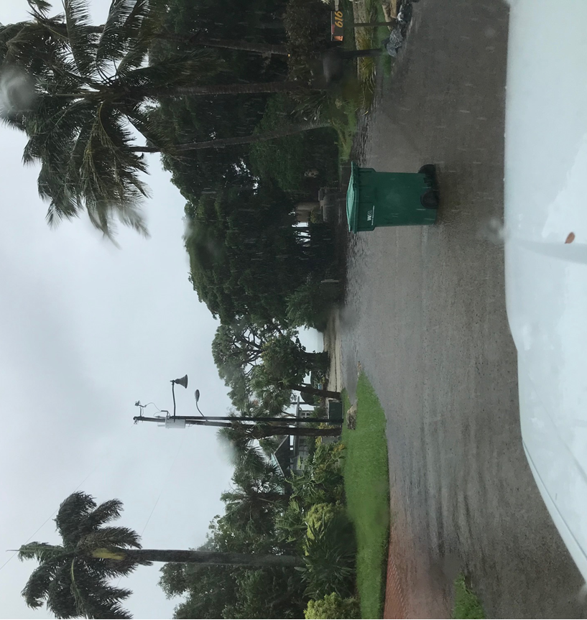
- Rountree Canal- Topping of Seawall
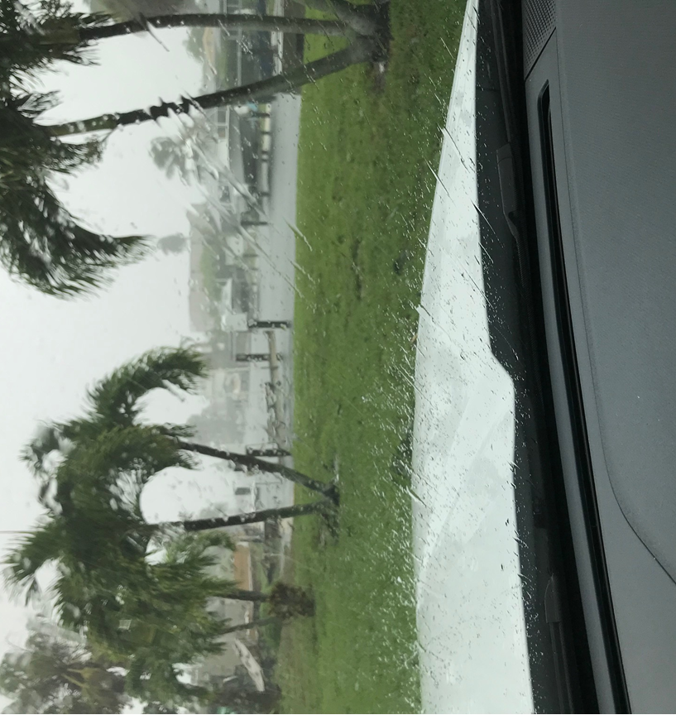
- GMD Flooding- In front of Casa Del Mar
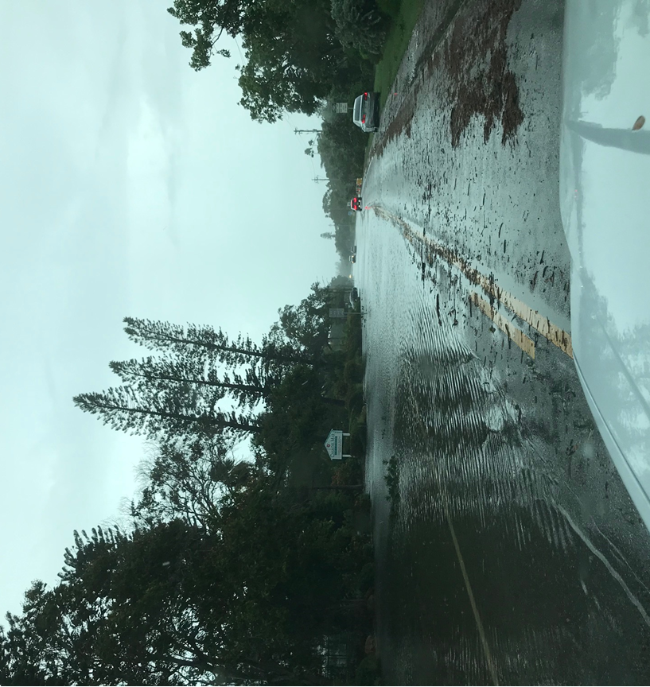
- GMD Flooding- In front of Zota Hotel
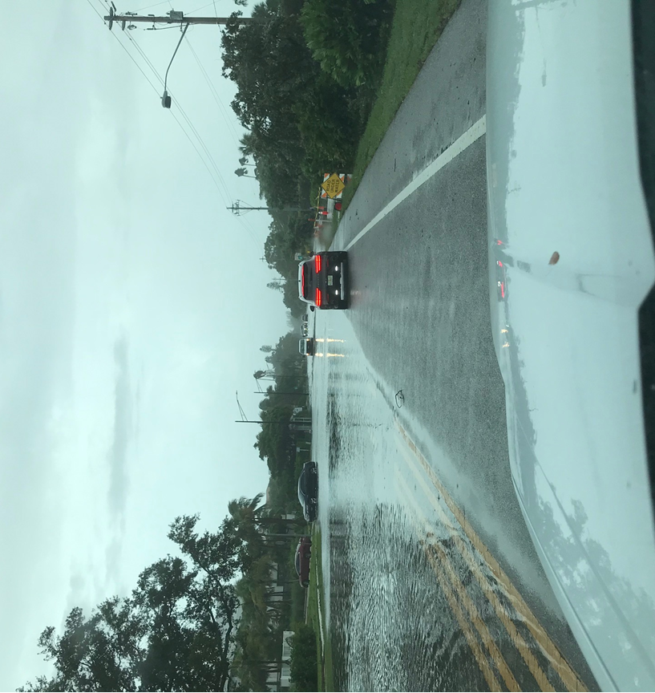
- GMD Flooding- In front of Covert Condos
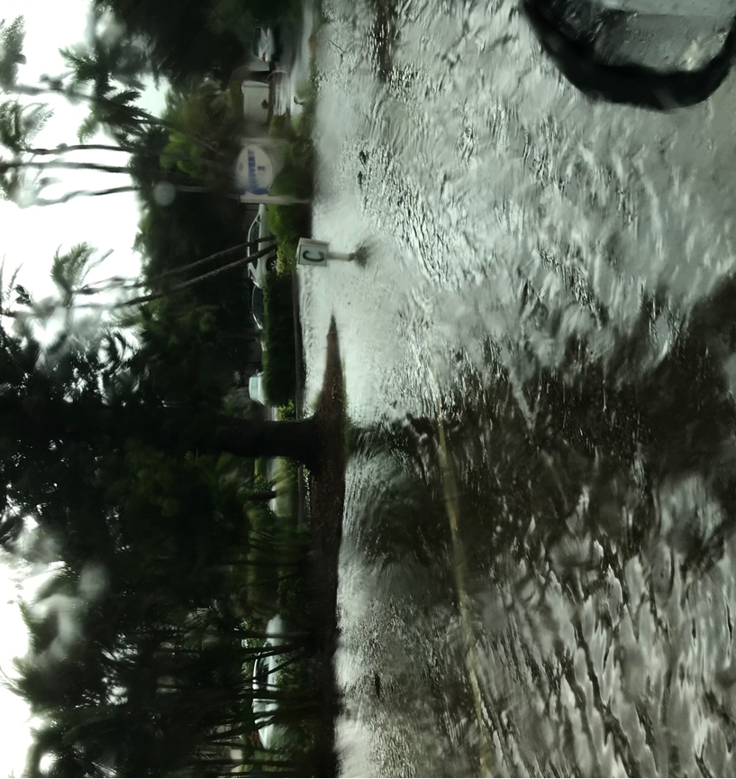

- Gulf Bay Rd.- Street Flooding
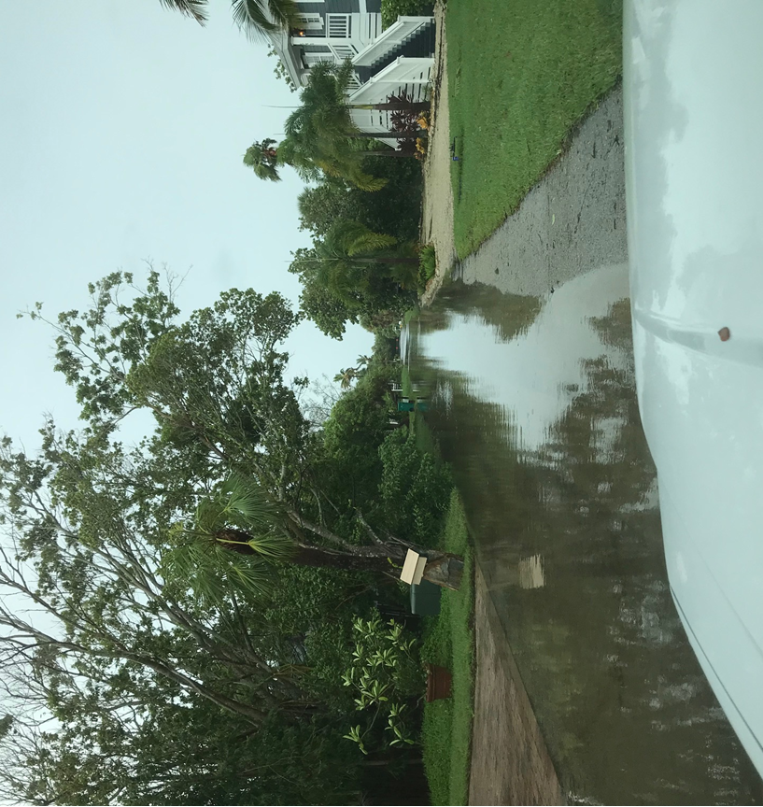

- St. Judes.- Street Flooding
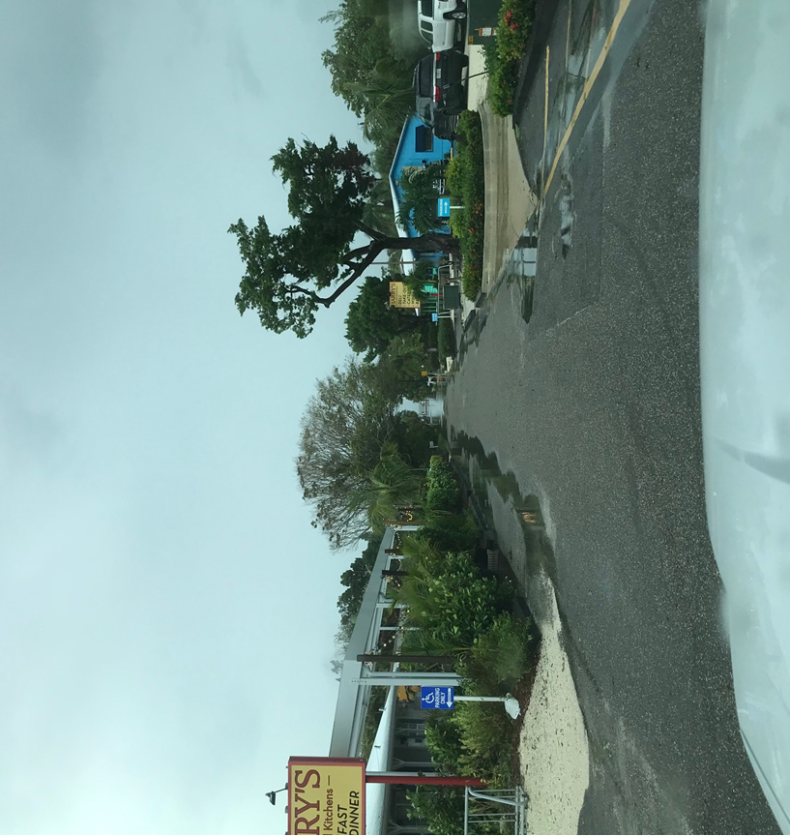

- Tarawitt Canal- Overtopping
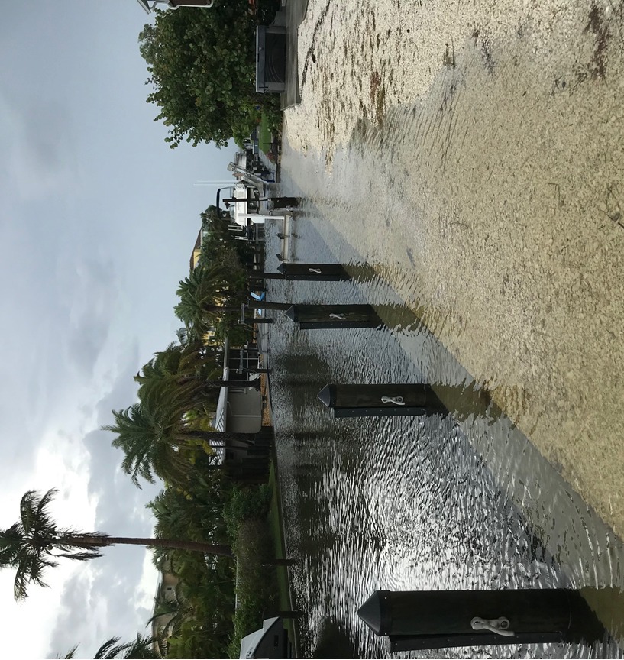

- Jungle Queen- Near Sarasota Bay- Street flooding

- Spanish Main- Interior Lake- No flooding, but high water level
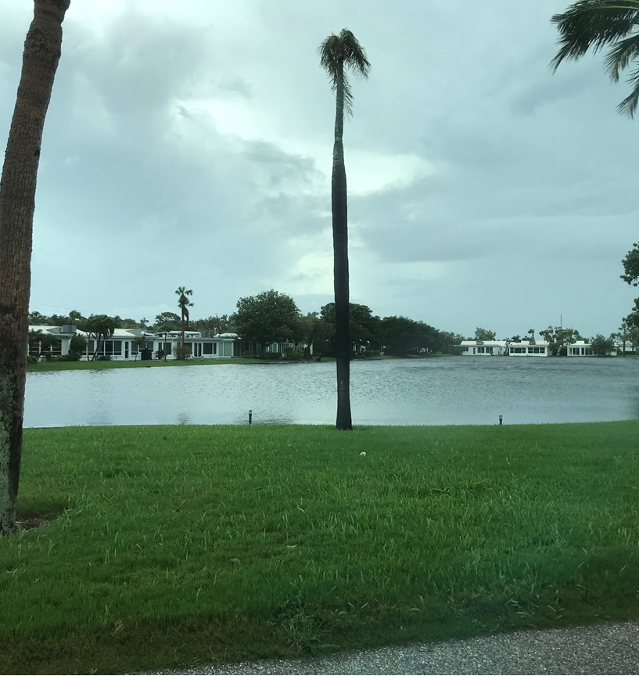

- Spanish Main Dr. S- Street flooding.
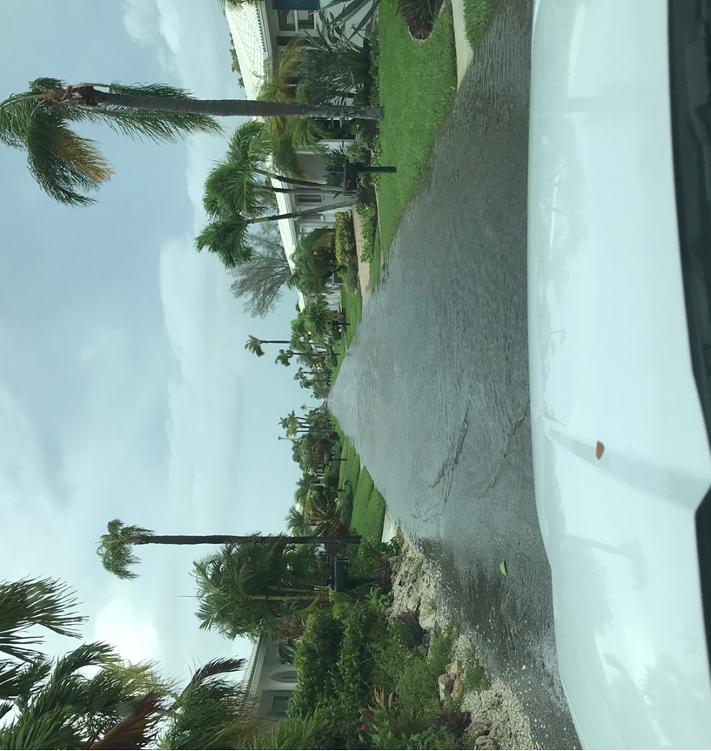

- Spanish Main Dr. N- Street flooding.
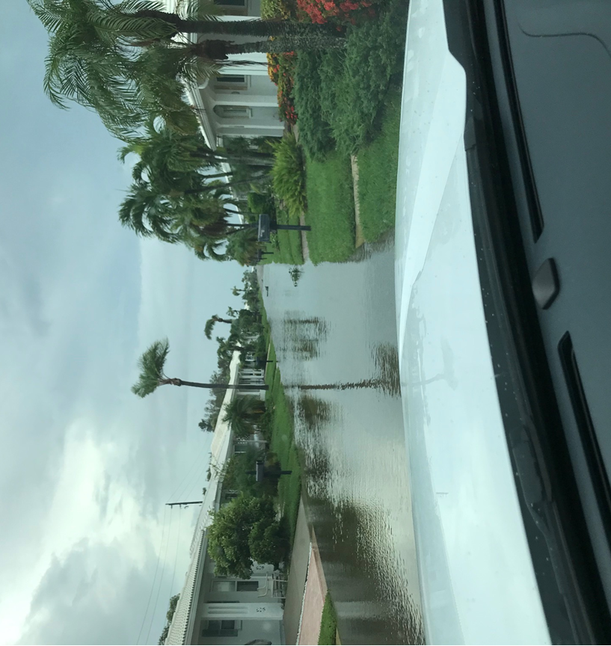

- Binnacle Pt.- Street flooding.
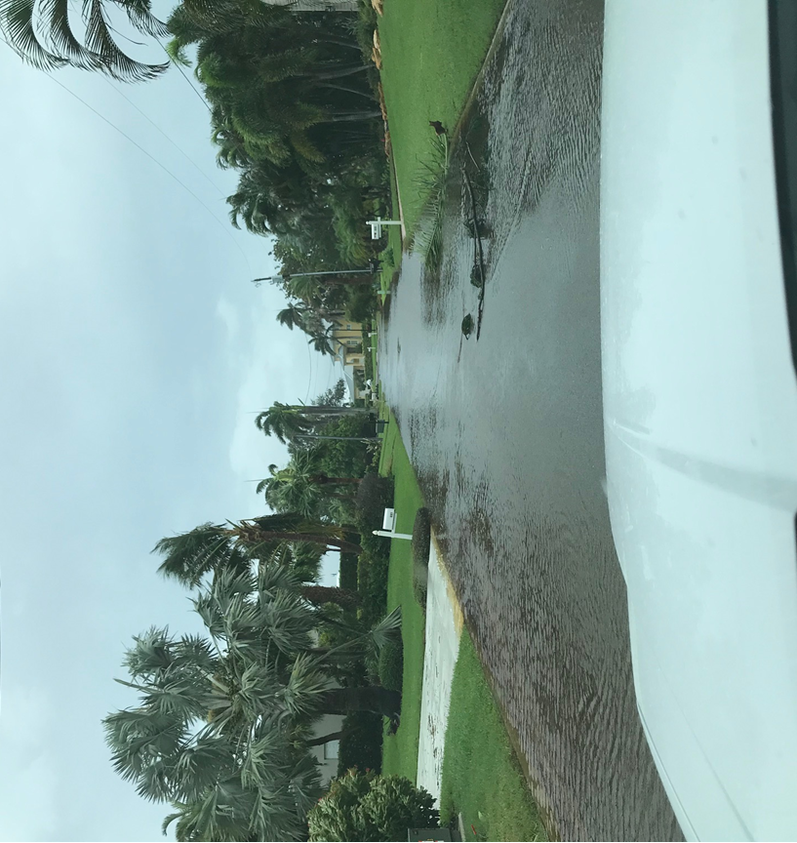

- Emerald Harbor Dr.- Street flooding.
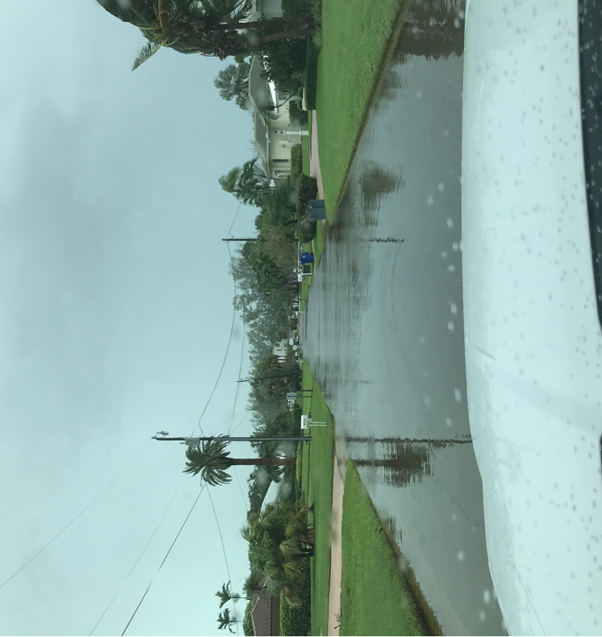

- Emerald Harbor Harbor Basin- Overtopping seawalls.
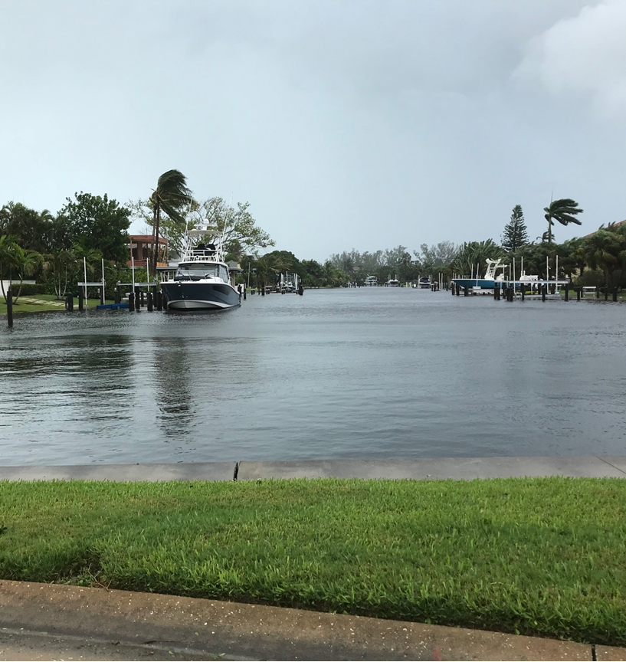

- General Harris- Street Flooding.
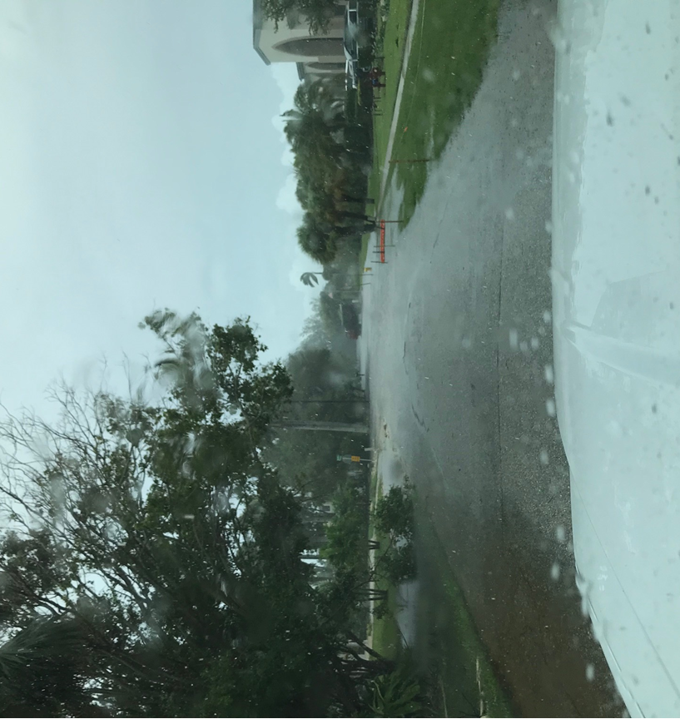

- Lyons Lane- Street Flooding.
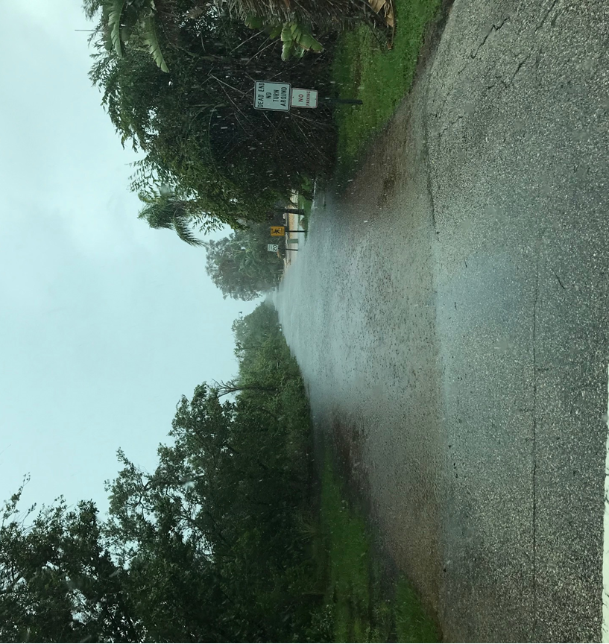

- Cedar St. (N. of Whitney Plaza)- Street Flooding.
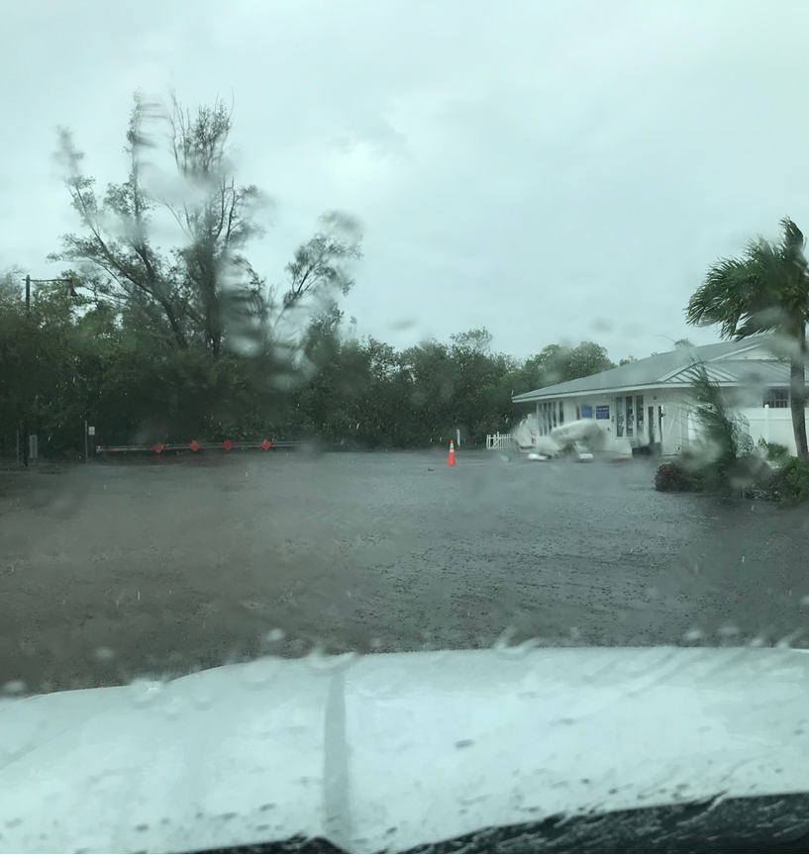

- Broadway- Street Flooding.
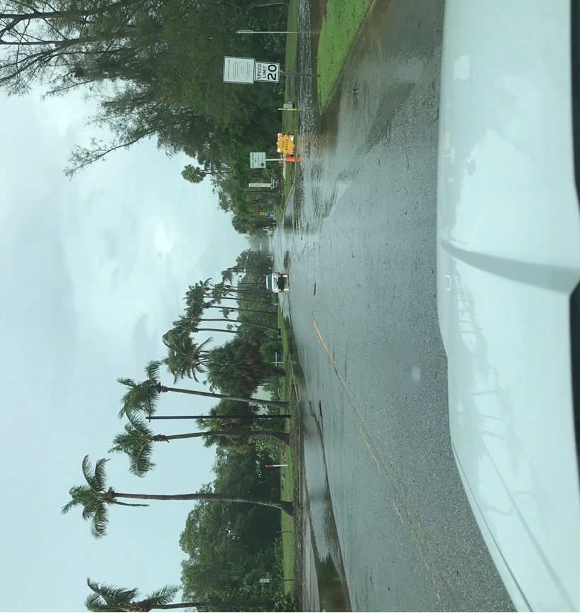
- Twin Shores Mobile Home Park- Street Flooding.
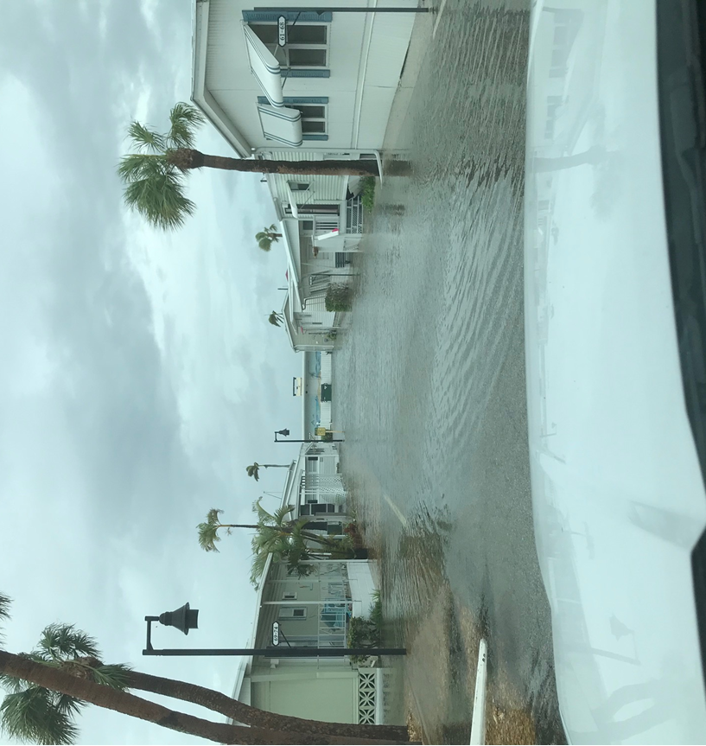

- Beach Access Point_ Near Town Hall (Beach Erosion)- Looking North.
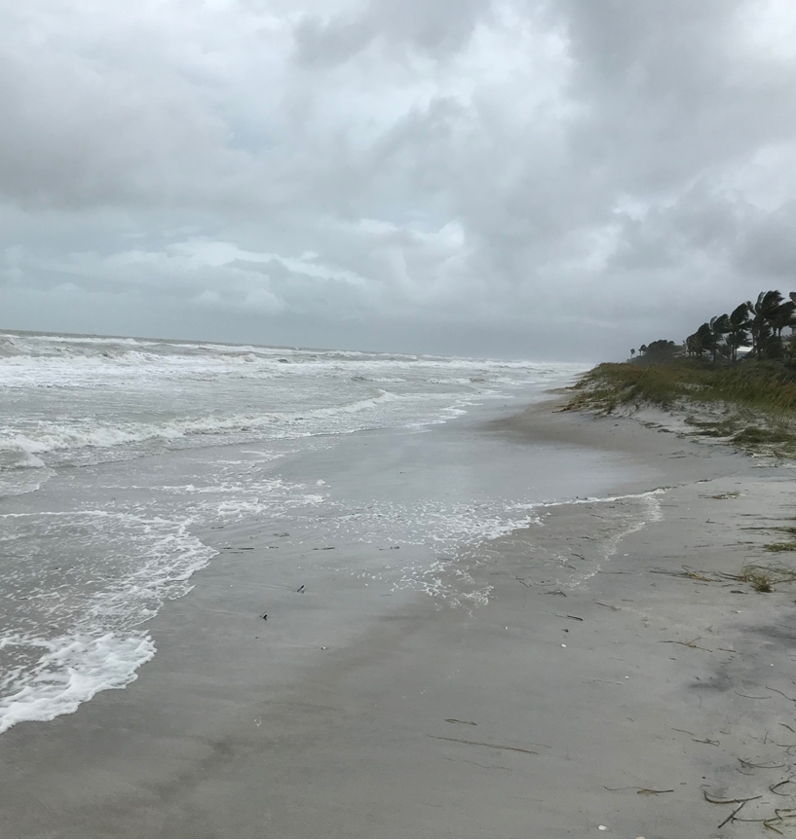
- Beach Access Point_ Near Town Hall (Beach Erosion)- Looking South.
