Change of Contractor

CTRL+F or from the address F6

OK

Click OK

Stipulations

Add the wording

03-24-2025 Homeowner Association requested the removal of Wrightway Emergency Services dba of Reynolds Ventures Inc as the contractor and change to Paradise Improvements approved by building official Patti Fige. See the letters in the file.

03-24-2025 Paradise Improvements provided an application to take over Permit PB24-1883 approved by Building Official Patti Fige.

Change the Contractor Name from the Old Contractor to the new one.

Press OK and then yes for the Paradise Improvements Inc also the applicant?

Press yes for the Would you like to select a valid Licensee now?

Click OK

Scan the Change of Contractor Form and attach to the Documents

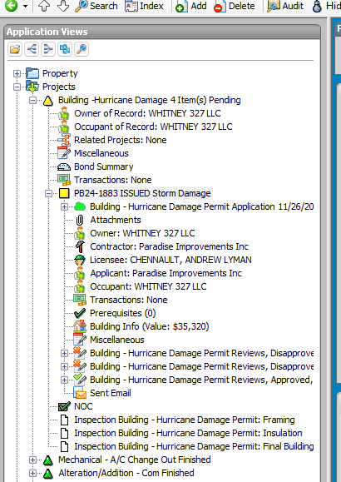

Attach documents to Attachments

Click OK

Transactions Add Invoice

Remove Fees

Add the Change of Contractor Fee

Send an e-mail to the contractor letting them know that the Change of Contractor has been approved and that there is an $85.00 Change of Contractor Fees, in the e-mail include the approved documents and the new permit card.

Print permit card and scan to e-mail.

