**Longboat Key Fire Rescue: A Year in Review – 2024**

**Mission and Commitment**  
The mission of Longboat Key Fire Rescue (LBKFR) is to protect life, property, and the environment by delivering exceptional emergency services through training, education, and customer service. Guided by our Mission, Vision, and Core Values, LBKFR remains deeply committed to enhancing the quality of life and safeguarding the property of Longboat Key, Florida.

As our slogan, **"Community First"**, reflects, the members of LBKFR are steadfast in prioritizing the community's well-being. Among our many accomplishments in 2022, our greatest achievement was ensuring the safety, health, and wellness of our team members. Maintaining a workforce that is physically fit, emotionally resilient, and prepared for high-stress, dangerous environments has been a central focus.

Through collaboration between labor and management, we strengthened our wellness initiatives, significantly enhancing the performance, effectiveness, and longevity of our most valuable resource: **our members**.

As we look back on 2024, the milestones achieved reflect our collective dedication to professionalism and service. Longboat Key Fire Rescue remains committed to excellence, innovation, and the safety of both our members and the community we serve.

**Overview of the 2024 Hurricane Season**

The Atlantic basin saw increased activity this year, with warmer-than-average sea surface temperatures and favorable atmospheric conditions contributing to a heightened number of storms. Longboat Key, despite its robust preparedness measures, was directly affected by three hurricanes, each leaving its mark on our community:

* **Hurricane Debby:** Brought significant storm surges and coastal flooding in early August. Quick action by emergency services ensured the safety of residents, though minor damage to beachfront properties and erosion were reported.
* **Hurricane Helene:** In September, Helene’s strong winds caused scattered power outages, downed trees, and structural damage to some homes. Thanks to proactive measures, including pre-storm debris clearing and enhanced communication, recovery efforts were swift.
* **Hurricane Milton:** A late-season storm in November, Milton delivered heavy rainfall and localized flooding, primarily affecting low-lying areas. Community members demonstrated remarkable cooperation during evacuation advisories, ensuring minimal injuries.

**Community Resilience and Response**

Our **Emergency Operations Team** once again showed exceptional dedication, working tirelessly to safeguard residents and property. Notable highlights include:

* **Advanced Notification & Communication:** Frequent updates were provided through emergency alert systems, social media, and local broadcasts.
* **Evacuation & Sheltering:** Shelters were activated in a timely manner, with residents utilizing these resources during Hurricane Milton.
* **Recovery Efforts:** Post-storm clean-up teams were deployed within hours of storm passage, ensuring roads were cleared and essential services restored.

**Gratitude for Our Community**

We extend our heartfelt gratitude to all residents for your cooperation and support during these challenging times. The proactive approach to evacuation orders, storm preparations, and post-storm recovery was instrumental in minimizing risks and damages.

**Looking Ahead**

As we plan for the 2025 hurricane season, we encourage employees and residents to stay informed, prepare early, and review their emergency plans. Together, we can continue to weather the storms and maintain the safety and beauty of our community.

1. **Key Accomplishments**

**1. Implementation and Revision of General Orders and Policies**

* Developed and updated policies to guide personnel during both emergency and non-emergency operations

**2. Public Education and Community Engagement**

* Published educational articles in various media outlets through our Public Information Officer (PIO)
* Continued the “Neighbors Helping Neighbors” initiative, providing resources during hurricane season
* Maintained daily updates across multiple social media platforms to keep the community informed

**3. Training Initiatives**

* Met training requirements for ISO (re)certification
* Updated modular training programs for new hires, including quarterly testing
* Conducted practical exercises using donated homes scheduled for demolition
* Held high-rise fire training programs designed by members who attended specialized training in Pensacola
* Provided annual water rescue, search-and-rescue, and vehicle extrication training
* Facilitated EMS-specific classes, such as airway management, pediatric care, and advanced documentation
* Trained personnel on new equipment prior to implementation
* Supported members in achieving Fire Inspector certifications
* All members achieved State Pump Operator course

**4. Uniform Upgrades**

* New uniforms implemented
* Established/revised a uniform inspection program

**5. Emergency Preparedness**

* Partnered with Sarasota and Manatee County Emergency Management to enhance disaster response
* Hosted a public seminar on severe weather preparedness, featuring guest speakers
* Updated department-wide hurricane operation plans
* Deployed the high-water vehicle during hurricane response

**6. EMS Advancements**

* Launched a new Quality Improvement team
* Implemented six shift EMS Field Trainers
* Revised and implemented numerous EMS protocols
* Trained and new paramedics as charge medics
* Purchased a Lucas Device for the use on cardiac arrest incidents

**7. Strategic Planning and Grants**

* Adopted and implemented a five-year Strategic Plan
* Secured multiple grants, including:
  + WCIND Grant for Marine Operations
  + County EMS Grant from FDOH
  + EMS State Grant

**8. Recognition and Morale**

* Held the annual Medal Day ceremony to honor outstanding member contributions

**9. Apparatus**

* Purchased a new rescue (received in January 2025)
* Ordered a new 100’ ladder truck
* Obtained a second high-water vehicle

**10. Personnel**

* Welcomed two new members to the fire department team

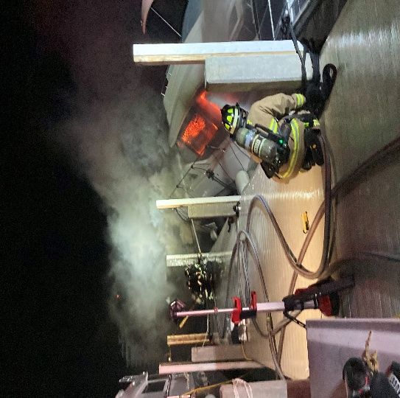

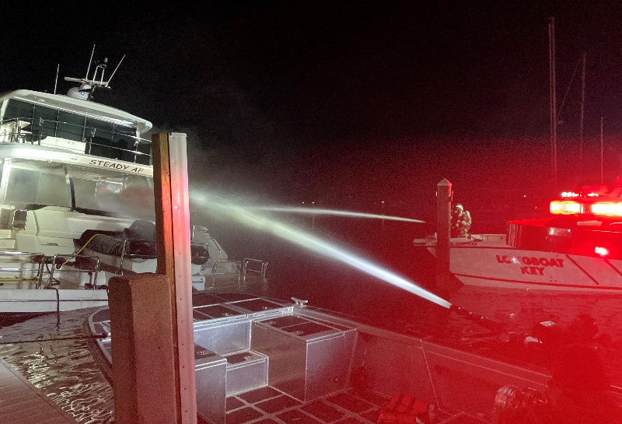

**Yacht fire at the Longboat Key Moorings**

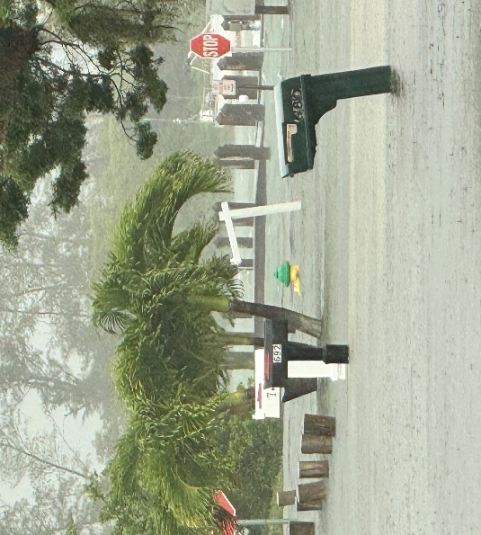 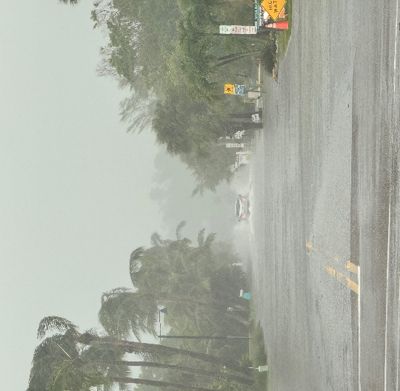

**Tropical Storm Debby**

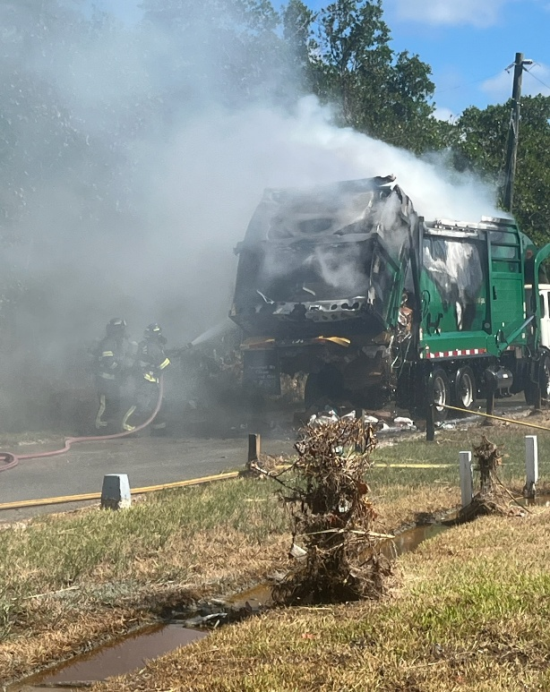 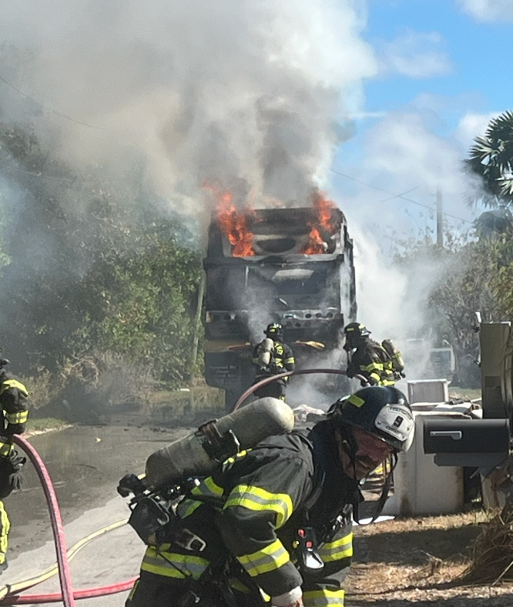

**Garbage Truck Fire**

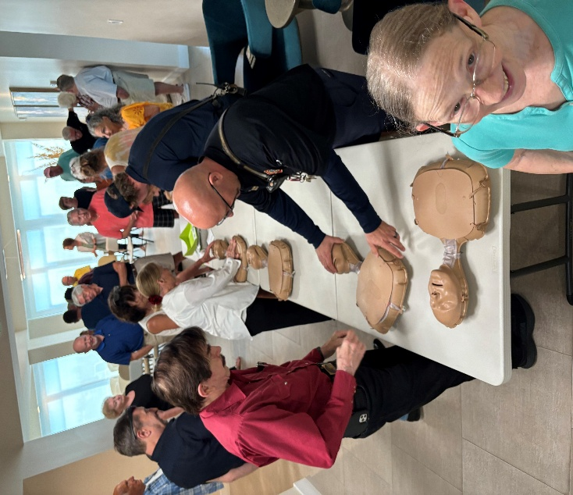 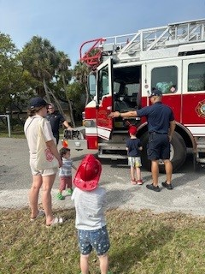

**Public Education**