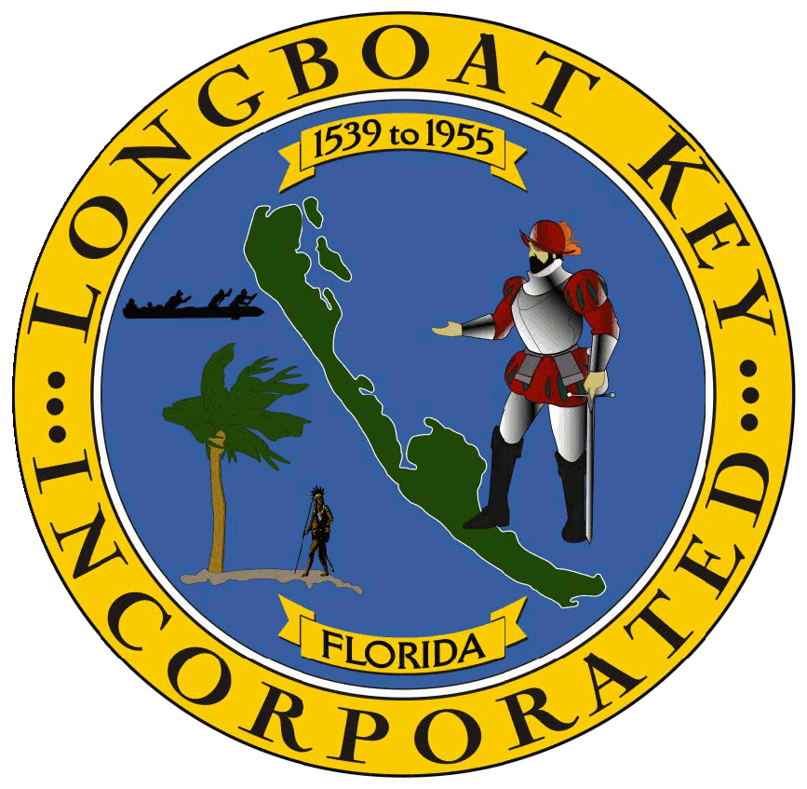PLANNING, ZONING & BUILDING DEPARTMENT

*Some* of the 2024 Accomplishments Summary

In No Particular Order

* Provided disaster response to 3 major hurricanes (Debbie, Helene & Milton). This year’s 3 landfalling hurricanes ties 1871, 1886, 1964, 2004 & 2005 as the years with the most landfalling hurricanes, in Florida, in a single season. Partial list of impacts:
  + 2,331 structures identified as being affected in Helene & Milton.
  + $190M estimated preliminary damage assessment amounts.
  + 850 permits issued (since Nov. 1st)!
  + Tons of extra hours worked.
  + Countless questions answered.
  + Proactive Code Enforcement halting unpermitted work.
  + Substantial Damage Estimates assessments & documentation that’s ongoing.
  + Pilot-tested new Flood Management Software System, (Forerunner), in part, to assist with timely providing Substantial Damage Estimates to property owners seeking insurance and grant funding
  + Community Resiliency Webinar: Navigating Recovery After the Storms online event held 12/19/24.
  + Waived building permit fees (through April 2025).
  + Extended construction noisemaking work activity hours (through January 2025).
  + Passed an Emergency ordinance to eliminate an unnecessary building permit requirement for single-family homes.
  + Trained multiple Permit Techs.
  + Coordinated with volunteers & FDEM personnel.
  + Responded to an in-depth FEMA post-storms visit with flying colors.
  + Worked to supplement staffing to deal with surge in permits & inquiries.
* Transitioning permitting software system (from BS&A to Accela). Staff mapped every existing workflow for all permits, P&Z applications, and Code Enforcement responsibilities. Staff verified that those workflows do what they’re supposed to do. Go-Live implementation is anticipated by 1st quarter of calendar year 2025. The new permitting system will accept all permits types electronically; contractors can schedule their own inspection time slots (provided they’re ready); inspectors and Code Enforcement will have full documenting, referencing & reporting capabilities in the field; and, the public will have a better system to self-service inquiries, etc.
* Speaking of new software that’ll be very helpful, as noted above, the Town will soon have access to a web-based floodplain management system, called [Forerunner](https://www.withforerunner.com/features/floodplain-compliance) (screenshot below). Forerunner has a number of easy-to-use & easy-for-the-public-to-access features that help with various record keeping aspects of the Community Rating System/National Flood Insurance Program (CRS/NFIP) requirements (the Program that makes NFIP policies available to property owners in the Town & at a 20% discount based on the many things the Town does as a part of that). It does automated Elevation Certificate (EC) error detection and allows property owners/insurance reps, etc. to get copies of their EC’s (or find out what FEMA flood zone their property is in). The system is going to help with the CRS audits & Cycle Verification requirements, & will assist in gaining additional CRS points, which can help the Town’s CRS rating & further increase policy holders’ discounts.  In the immediate future the Town will be using the system to help us with organizing, generating, & documenting Substantial Damage Determination letters, which are a key component of certain insurance and grant funding requirements by property owners substantially damaged by hurricanes.

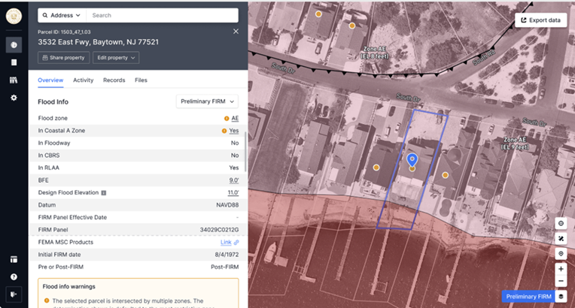

* Town staff worked an extensive amount of overtime to assist with getting the large and complex St. Regis project to a Temporary Certificate of Occupancy status, allowing the hotel to have a soft opening in the early summer. (A link to very cool early summer drone footage of the project is [here](https://drive.google.com/drive/folders/1MuVdYuvuDNYPrMiT7yaqcp1R9Em0VorI)).

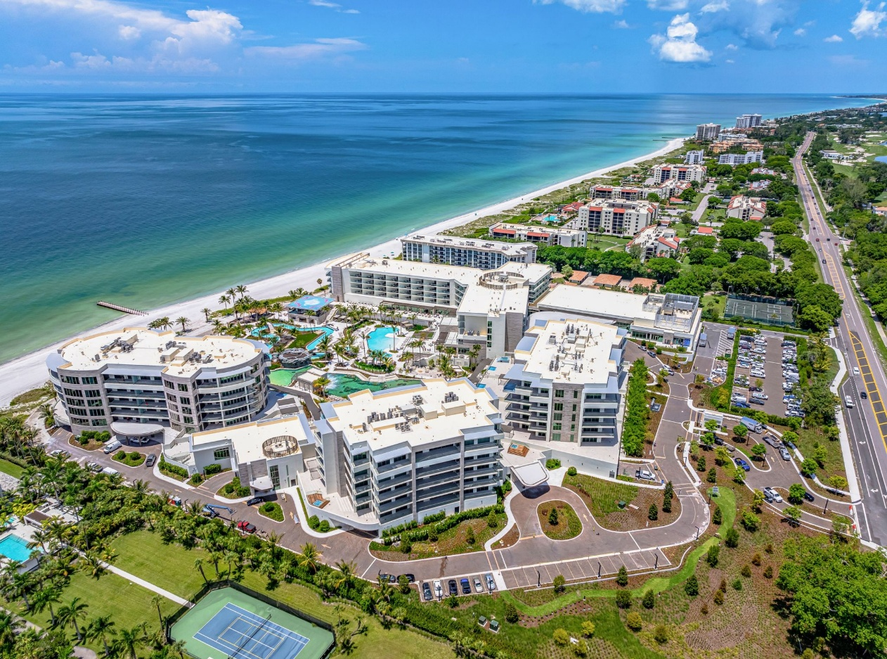

* Code Enforcement worked closely with St. Regis regarding ongoing sea turtle lighting violations at the property. The end result (after 2 delays for 2 hurricanes) was a finding of a violation, by the Town’s Special Magistrate, at the property, which sets the stage for better future compliance.
* Completed the public hearings on the ‘Batched’ updates to the Town’s Comprehensive Plan (Plan), with final approval of the ordinance that adopted updates to the Housing, Governance and Capital Improvement Elements (Batch 6) in June.
* Developed the Town’s first ever feasibility study assessing the impacts of the de-annexation (or contraction) of Jewfish Key. The attorneys representing property owners seeking to de-annex, withdrew their request following release of the report.
* In the Fall, started on the Comprehensive Plan Implementation, ‘To-Do List’ and will be working through the business of providing recommendations for the implementation of the Policies and Strategies that are called for in the Plan.
* Passed the Community Rating Systems (CRS) Program Recertification audit. Their review of our Elevation Certificates had a “correctness rate of 92%.” In order to pass the audit, jurisdictions have to have a 90% minimum correctness threshold. Congrats & thank you to the Town’s Plan Reviewers who check these incredibly detailed certificates!
* Nearing completion on the first grouping of milestone reports to [recertify certain condominium buildings](https://www.longboatkey.org/town-government/departments/planning-zoning-building/building-recertification) for structural integrity. The new state law (Florida Statute 553.899), which went into effect on May 26, 2022, created new requirements for "Milestone Inspections," which primarily address the structural integrity of condominium and cooperative association buildings that are three stories or more in height and are 30 or more years old. Most of the applicable properties and buildings have been received. Also developed an [online inventory](https://longboatkey.maps.arcgis.com/apps/instant/interactivelegend/index.html?appid=240afc4a526d4ef4855ddd5b3200a3cb) of condos greater than 3 stories tall.
* Property owners in the Manatee Co. portion of the Town were provided a periodic notice, by the Army Corps of Engineers, that some of them live in what was a World War II Bomb & Gun Range. Property owners were informed that that their properties may have potential explosive hazards & what to do if they encounter those. Bombing range area shown below:

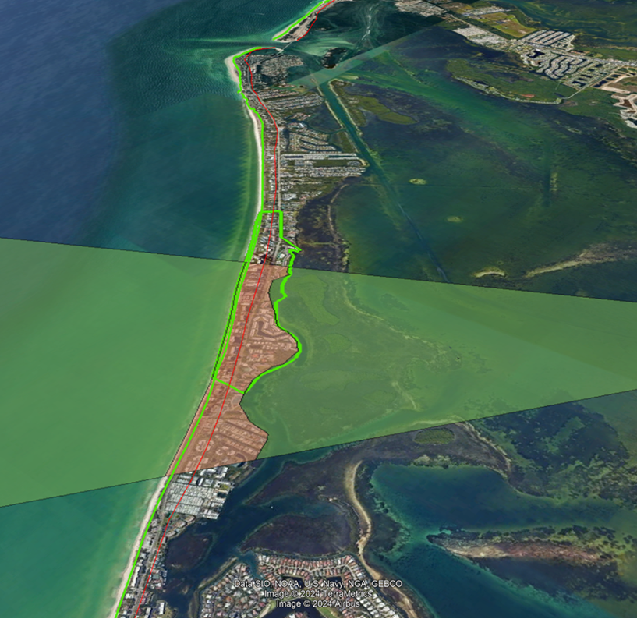

**New/Amended Ordinances/Resolutions**

* Ord. 2024-02: Adopting amendments to Housing, Governance and Capital Improvements Elements of the Comprehensive Plan (“Batch 6”).
* Ord. 2024-04: Approval of one of the near-term implementation items (Action 2) from the Town’s recently accepted Sea Level Rise and Recurring Flooding Resilience Plan (SLR Plan). The ordinance amended the Shoreline Construction (Town Code Ch. 151) provisions that regulate the maximum allowable seawall elevation height from 4.5 feet “North American Vertical Datum” (NAVD) to up to 6 feet NAVD.
* Ord. 2024-03: Allows property owners to elect to include up to 3 total feet of Freeboard height. Election of additional Freeboard height affects the point at which the Town measures height from, which is the Federal Emergency Management Agency (FEMA), Base Flood Elevation (BFE) requirement, plus the amount of Freeboard provided. The net result will allow for up to an additional 2 feet of height, greater than that allowed by the prior mandatory 1-foot of Freeboard requirement. This net difference of 2 additional feet of Freeboard height also essentially allows structures to achieve the same heights that were allowable under the prior FEMA flood elevation maps (new maps were adopted in 2024 for the Sarasota County side of the island and in 2021 for the Manatee County side).
* Ord. 2024-06: Was a Town-initiated amendment, on behalf of a telecommunications provider, to the ancillary equipment dimensional standards applicable to personal wireless facilities mounted on existing lighting poles. The revised standards allow ancillary equipment to be either attached or adjacent to a light/utility pole, to utilize an equivalent cubic foot volume for the cabinet size and allowing an additional foot of height (up to 36’) for antennas on top of poles along Gulf of Mexico Drive.
* Ord. 2024-07: Allows an extra additional 2 feet of Freeboard height (in addition to the overall total of 3 feet incorporated into Ordinance 2024-03) for properties in low-lying areas with existing average property ground elevation at or below 3.5 feet NAVD.
* Res. 2024-18: Is an updated Building/Fire Fee Resolution that includes a number of updates (such as a Master Building Permit fee), some consolidations (of duplicative fees), some increases (e.g. Stop Work Orders) & some reductions (e.g. Milestone Reports). The new Fee Resolution will become effective April 1, 2025, in order to have the new fees incorporated into Accela & to give an extended heads-up to the public that there’ll be updated fees.
* Res. 2024-26: Extended the waivers of certain building fees for storm damage repair (until April 30th).

**Short List of Anticipated 2025 Items**

* Supplementing permit intake, plans review & inspection staffing to deal with storm repairs & rebuilding.
* Getting out Substantial Damage Letters to properties damaged beyond 50% of their assessed values.
* Going live with new permitting system.
* Getting access to all staff & the public of the Forerunner flood management system.
* C.O.’ing the new St. Regis project (buildings, individual units, and hotel components).
* Providing review and recommendations on Town’s Parks and Open Space Land Acquisition fees.
* Amending standards for dock and boat lift heights.
* Follow-up implementation items directed from the Comprehensive Plan, including: 1) Encouraging renewable energy use options (FLU Policy 1.1.4); 2) Evaluation of potential Land Development Code (LDC) changes associated with online consumer activities, and delivery methods (FLU Policy 1.4.6); and 3) Encouraging property owners to retrofit structures with storm resistant materials and ensuring that the LDC and other codes do not unreasonably impede the retrofitting of structures for storm resistance (CCM Strategy 3.1.1.2).
* Telecommunications ordinance amendments associated with private provider equipment requirements.