**Where does the money come from?**

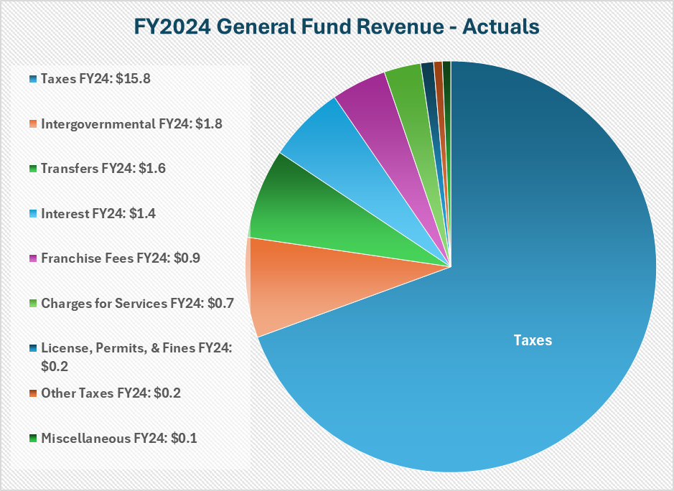

The Town of Longboat Key collected just over $22.8 million in revenue in its General Fund in FY2024 which exceeded budget estimates by $1.7 million. This was in large part due to the Town collecting $940,000 more in interest than budgeted, from the continuation of elevated Federal Funds interest rates. Property taxes make up 69% of all revenues at $15.8 million. Other revenues include State sales tax, communication services taxes, franchise fees (electric, natural gas, solid waste), ambulance billing fees and interest income. The Town’s total revenue came in at 107.95% of the Budget for FY2024.

**What does the money pay for?**

The largest portion of expenditures in the General Fund is devoted to keeping residents safe. Police, Fire and Ambulance makes up 63% of the operating budget. Other general government services – like Town Administration, Legal, I.T., Purchasing, Human Resources, Finance, Planning & zoning – make up 27% of the General Fund budget. Public Works Administration, Streets and Facilities, accounts for 8% and Parks and Recreation makes up 2% of the budget. The Total Operating Budget Expenditures came to $19.9 million for FY2024. In addition, the Town transferred $5.35 million to Capital Project Funds targeting strategic initiatives. The Town total spending came in at 97.3% of the Total Budget for FY2024.

**FY2024 General Fund Expenditures - Actuals**

63% 27**%** 8**%** 2%

Public Safety **$12.6 million**

Public Safety General Government Public Works, Parks & Recreation

Streets & Facilities



Public Works, Streets & Facilities **$1.6 million**

Transfer to Capital Improvements **$5.4 million**

Parks & Recreation **$0.3 million**

General Government **$5.4 million**