Town Commission The Town has a Commission/Manager form of government. Seven Commissioners are elected for three-year terms. Elections are held annually as terms expire. Each year, the Town Commission selects a Commissioner to serve as the Mayor. The Town has five Commission districts and two At-Large Commission seats. All Commissioners are elected Town-wide. The Town Manager is appointed by the Commission and administers the daily operations of the Town through appointed department heads.

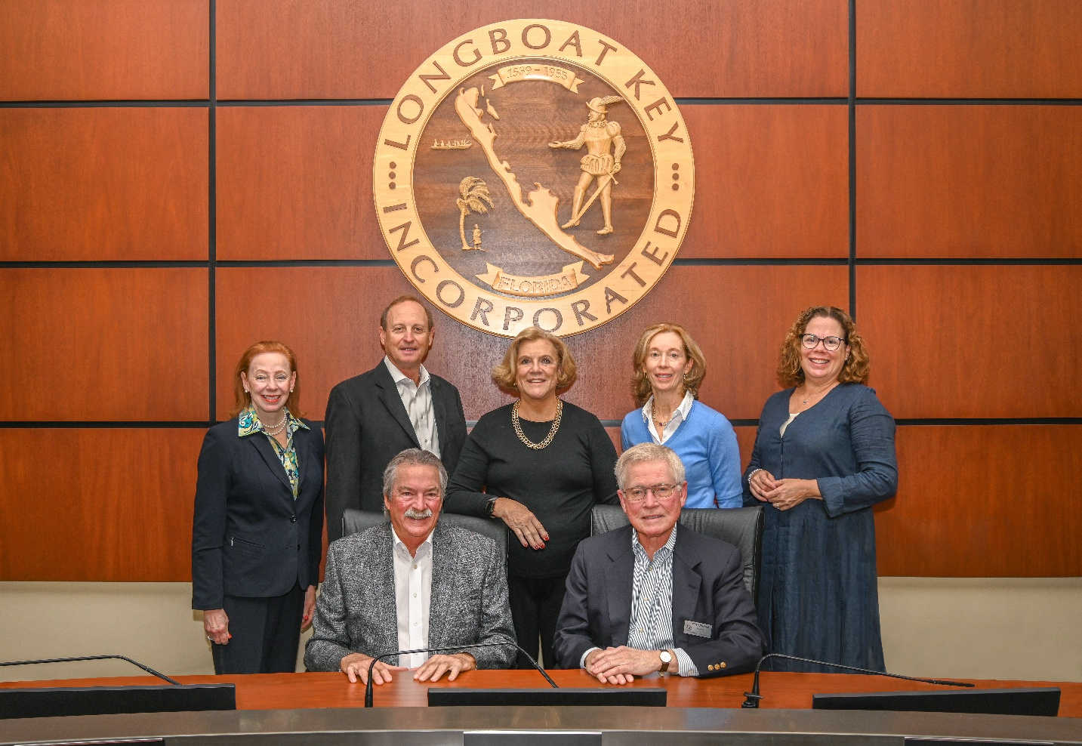

Back row (left to right): Penny Gold, Commissioner District 2; Gary Coffin, Commissioner District 1; B.J. Bishop, Commissioner At-Large; Debra Williams, Commissioner District 4; Sarah Karon, Commissioner District 5

Front row (left to right): Ken Schneier, Mayor & Commissioner District 3; Mike Haycock, Vice-Mayor and Commissioner At-Large